|  |  |  |
| --- | --- | --- |
| C:\ProgramData\WebLog Expert Lite\Report\index_files\section_left.gif | **Summary** | C:\ProgramData\WebLog Expert Lite\Report\index_files\section_right.gif |

**Summary**

|  |
| --- |
|  |

|  |  |  |  |  |  |  |  |  |  |  |  |  |  |  |  |  |  |  |  |  |  |  |  |  |  |  |  |  |  |  |  |  |  |  |  |  |  |  |  |  |  |  |  |  |  |  |
| --- | --- | --- | --- | --- | --- | --- | --- | --- | --- | --- | --- | --- | --- | --- | --- | --- | --- | --- | --- | --- | --- | --- | --- | --- | --- | --- | --- | --- | --- | --- | --- | --- | --- | --- | --- | --- | --- | --- | --- | --- | --- | --- | --- | --- | --- | --- |
| |  |  | | --- | --- | | **Hits** | | | Total Hits | 5,288,303 | | Visitor Hits | 5,288,298 | | Spider Hits | 5 | | Average Hits per Day | 661,037 | | Average Hits per Visitor | 261.46 | | Cached Requests | 0 | | Failed Requests | 87,618 | | **Page Views** | | | Total Page Views | 5,288,066 | | Average Page Views per Day | 661,008 | | Average Page Views per Visitor | 261.45 | | **Visitors** | | | Total Visitors | 20,226 | | Average Visitors per Day | 2,528 | | Total Unique IPs | 16,084 | | **Bandwidth** | | | Total Bandwidth | 12.67 GB | | Visitor Bandwidth | 12.67 GB | | Spider Bandwidth | 80 B | | Average Bandwidth per Day | 1.58 GB | | Average Bandwidth per Hit | 2.51 KB | | Average Bandwidth per Visitor | 656.83 KB | |

|  |  |  |
| --- | --- | --- |
| C:\ProgramData\WebLog Expert Lite\Report\index_files\section_left.gif | **Daily** | C:\ProgramData\WebLog Expert Lite\Report\index_files\section_right.gif |

**Daily Visitors**  
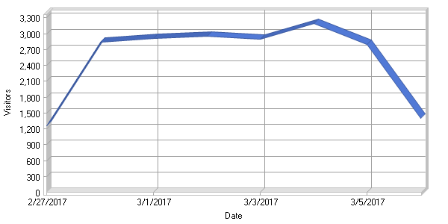

**Daily Activity**

|  |
| --- |
|  |

|  |  |  |  |  |  |  |  |  |  |  |  |  |  |  |  |  |  |  |  |  |  |  |  |  |  |  |  |  |  |  |  |  |  |  |  |  |  |  |  |  |  |  |  |  |  |  |  |  |  |  |  |  |  |  |  |  |  |  |  |  |  |  |
| --- | --- | --- | --- | --- | --- | --- | --- | --- | --- | --- | --- | --- | --- | --- | --- | --- | --- | --- | --- | --- | --- | --- | --- | --- | --- | --- | --- | --- | --- | --- | --- | --- | --- | --- | --- | --- | --- | --- | --- | --- | --- | --- | --- | --- | --- | --- | --- | --- | --- | --- | --- | --- | --- | --- | --- | --- | --- | --- | --- | --- | --- | --- |
| |  |  |  |  |  |  | | --- | --- | --- | --- | --- | --- | | **Date** | **Hits** | **Page Views** | **Visitors** | **Average Visit Length** | **Bandwidth (KB)** | | Mon 2/27/2017 | 239,950 | 239,936 | 1,254 | 13:47 | 662,254 | | Tue 2/28/2017 | 1,022,043 | 1,022,011 | 2,837 | 05:53 | 2,741,756 | | Wed 3/1/2017 | 711,682 | 711,650 | 2,904 | 05:02 | 2,553,336 | | Thu 3/2/2017 | 996,255 | 996,221 | 2,951 | 05:18 | 2,224,253 | | Fri 3/3/2017 | 535,136 | 535,089 | 2,901 | 05:55 | 1,613,195 | | Sat 3/4/2017 | 936,669 | 936,637 | 3,189 | 05:18 | 1,494,073 | | Sun 3/5/2017 | 620,007 | 619,976 | 2,797 | 05:51 | 1,318,533 | | Mon 3/6/2017 | 226,561 | 226,546 | 1,393 | 03:48 | 677,575 | | **Total** | **5,288,303** | **5,288,066** | **20,226** | **05:56** | **13,284,980** | | | |
| C:\ProgramData\WebLog Expert Lite\Report\index_files\section_left.gif | **By Hour of Day** | C:\ProgramData\WebLog Expert Lite\Report\index_files\section_right.gif |

**Activity by Hour of Day**  
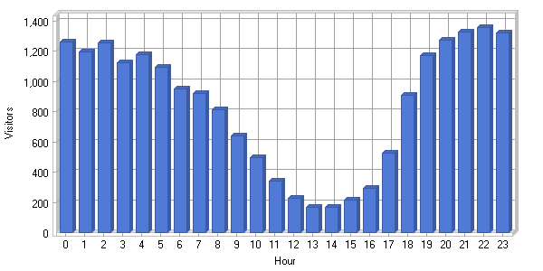

**Activity by Hour of Day**

|  |
| --- |
|  |

|  |  |  |  |  |  |  |  |  |  |  |  |  |  |  |  |  |  |  |  |  |  |  |  |  |  |  |  |  |  |  |  |  |  |  |  |  |  |  |  |  |  |  |  |  |  |  |  |  |  |  |  |  |  |  |  |  |  |  |  |  |  |  |  |  |  |  |  |  |  |  |  |  |  |  |  |  |  |  |  |  |  |  |  |  |  |  |  |  |  |  |  |  |  |  |  |  |  |  |  |  |  |  |  |  |  |  |  |  |  |  |  |  |  |  |  |  |  |  |  |  |  |  |  |  |  |  |  |  |  |  |
| --- | --- | --- | --- | --- | --- | --- | --- | --- | --- | --- | --- | --- | --- | --- | --- | --- | --- | --- | --- | --- | --- | --- | --- | --- | --- | --- | --- | --- | --- | --- | --- | --- | --- | --- | --- | --- | --- | --- | --- | --- | --- | --- | --- | --- | --- | --- | --- | --- | --- | --- | --- | --- | --- | --- | --- | --- | --- | --- | --- | --- | --- | --- | --- | --- | --- | --- | --- | --- | --- | --- | --- | --- | --- | --- | --- | --- | --- | --- | --- | --- | --- | --- | --- | --- | --- | --- | --- | --- | --- | --- | --- | --- | --- | --- | --- | --- | --- | --- | --- | --- | --- | --- | --- | --- | --- | --- | --- | --- | --- | --- | --- | --- | --- | --- | --- | --- | --- | --- | --- | --- | --- | --- | --- | --- | --- | --- | --- | --- | --- | --- |
| |  |  |  |  |  | | --- | --- | --- | --- | --- | | **Hour** | **Hits** | **Page Views** | **Visitors** | **Bandwidth (KB)** | | 00:00 - 00:59 | 247,264 | 247,244 | 1,262 | 655,933 | | 01:00 - 01:59 | 249,285 | 249,267 | 1,198 | 657,218 | | 02:00 - 02:59 | 240,078 | 240,060 | 1,255 | 661,232 | | 03:00 - 03:59 | 235,441 | 235,428 | 1,127 | 667,835 | | 04:00 - 04:59 | 233,467 | 233,460 | 1,178 | 589,748 | | 05:00 - 05:59 | 226,372 | 226,358 | 1,097 | 525,248 | | 06:00 - 06:59 | 214,780 | 214,768 | 948 | 584,181 | | 07:00 - 07:59 | 251,847 | 251,834 | 918 | 780,698 | | 08:00 - 08:59 | 278,613 | 278,607 | 812 | 760,123 | | 09:00 - 09:59 | 299,205 | 299,204 | 640 | 676,851 | | 10:00 - 10:59 | 246,298 | 246,292 | 499 | 557,802 | | 11:00 - 11:59 | 270,632 | 270,627 | 338 | 563,042 | | 12:00 - 12:59 | 202,900 | 202,899 | 225 | 370,841 | | 13:00 - 13:59 | 150,278 | 150,275 | 170 | 270,293 | | 14:00 - 14:59 | 110,601 | 110,600 | 165 | 199,025 | | 15:00 - 15:59 | 138,645 | 138,642 | 217 | 228,177 | | 16:00 - 16:59 | 143,655 | 143,651 | 293 | 253,563 | | 17:00 - 17:59 | 146,233 | 146,224 | 526 | 315,183 | | 18:00 - 18:59 | 175,559 | 175,552 | 908 | 441,919 | | 19:00 - 19:59 | 212,502 | 212,483 | 1,172 | 645,641 | | 20:00 - 20:59 | 230,063 | 230,047 | 1,272 | 695,194 | | 21:00 - 21:59 | 261,084 | 261,073 | 1,327 | 785,490 | | 22:00 - 22:59 | 264,991 | 264,977 | 1,359 | 721,932 | | 23:00 - 23:59 | 258,510 | 258,494 | 1,320 | 677,800 | | **Total** | **5,288,303** | **5,288,066** | **20,226** | **13,284,980** | |

|  |  |  |
| --- | --- | --- |
| C:\ProgramData\WebLog Expert Lite\Report\index_files\section_left.gif | **Pages** | C:\ProgramData\WebLog Expert Lite\Report\index_files\section_right.gif |

**Daily Page Access**  
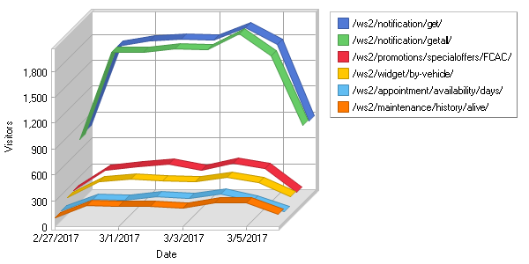

**Most Popular Pages**  
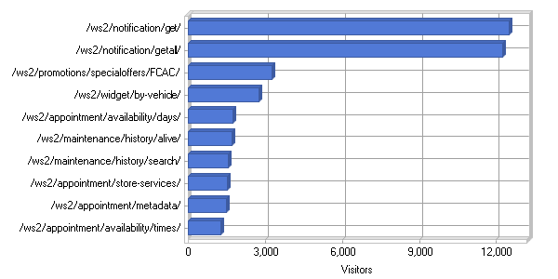

**Most Popular Pages**

|  |
| --- |
|  |

|  |  |  |  |  |  |  |  |  |  |  |  |  |  |  |  |  |  |  |  |  |  |  |  |  |  |  |  |  |  |  |  |  |  |  |  |  |  |  |  |  |  |  |  |  |  |  |  |  |  |  |  |  |  |  |  |  |  |  |  |  |  |  |  |  |  |  |  |  |  |  |  |  |  |  |  |  |  |  |  |  |  |  |  |  |  |  |  |  |  |  |  |  |  |  |  |  |  |  |  |  |  |  |  |  |  |  |  |  |  |  |  |  |  |  |  |  |  |  |  |  |  |  |  |  |  |  |  |  |  |  |  |  |  |  |  |  |  |  |  |  |  |  |  |  |  |  |  |  |  |  |  |  |  |  |  |  |  |  |  |  |  |  |  |  |  |  |  |  |  |  |  |  |  |  |  |  |  |  |  |  |  |  |  |  |  |  |  |  |  |  |  |  |  |  |  |  |  |  |  |  |  |  |  |  |  |  |  |  |  |  |  |  |  |  |  |  |  |  |  |  |  |  |  |  |  |  |  |  |  |  |  |  |  |  |  |  |  |  |  |  |  |  |  |  |  |  |  |  |  |  |  |  |  |  |  |  |  |  |  |  |  |  |  |  |  |  |  |  |  |  |  |  |  |  |  |  |  |  |  |  |  |  |  |  |  |  |  |  |  |  |  |  |  |  |  |  |  |  |  |  |  |  |  |  |  |  |  |  |  |  |  |  |  |  |  |  |  |  |
| --- | --- | --- | --- | --- | --- | --- | --- | --- | --- | --- | --- | --- | --- | --- | --- | --- | --- | --- | --- | --- | --- | --- | --- | --- | --- | --- | --- | --- | --- | --- | --- | --- | --- | --- | --- | --- | --- | --- | --- | --- | --- | --- | --- | --- | --- | --- | --- | --- | --- | --- | --- | --- | --- | --- | --- | --- | --- | --- | --- | --- | --- | --- | --- | --- | --- | --- | --- | --- | --- | --- | --- | --- | --- | --- | --- | --- | --- | --- | --- | --- | --- | --- | --- | --- | --- | --- | --- | --- | --- | --- | --- | --- | --- | --- | --- | --- | --- | --- | --- | --- | --- | --- | --- | --- | --- | --- | --- | --- | --- | --- | --- | --- | --- | --- | --- | --- | --- | --- | --- | --- | --- | --- | --- | --- | --- | --- | --- | --- | --- | --- | --- | --- | --- | --- | --- | --- | --- | --- | --- | --- | --- | --- | --- | --- | --- | --- | --- | --- | --- | --- | --- | --- | --- | --- | --- | --- | --- | --- | --- | --- | --- | --- | --- | --- | --- | --- | --- | --- | --- | --- | --- | --- | --- | --- | --- | --- | --- | --- | --- | --- | --- | --- | --- | --- | --- | --- | --- | --- | --- | --- | --- | --- | --- | --- | --- | --- | --- | --- | --- | --- | --- | --- | --- | --- | --- | --- | --- | --- | --- | --- | --- | --- | --- | --- | --- | --- | --- | --- | --- | --- | --- | --- | --- | --- | --- | --- | --- | --- | --- | --- | --- | --- | --- | --- | --- | --- | --- | --- | --- | --- | --- | --- | --- | --- | --- | --- | --- | --- | --- | --- | --- | --- | --- | --- | --- | --- | --- | --- | --- | --- | --- | --- | --- | --- | --- | --- | --- | --- | --- | --- | --- | --- | --- | --- | --- | --- | --- | --- | --- | --- | --- | --- | --- | --- | --- | --- | --- | --- | --- | --- | --- | --- | --- | --- | --- | --- | --- | --- | --- | --- | --- | --- | --- | --- | --- | --- | --- | --- | --- | --- | --- | --- | --- | --- | --- | --- | --- | --- |
| |  |  |  |  |  |  | | --- | --- | --- | --- | --- | --- | |  | **Page** | **Hits** | **Incomplete Requests** | **Visitors** | **Bandwidth (KB)** | | 1 | [http://www.api-aem.bsro.com/ ws2/notification/get/](http://www.api-aem.bsro.com/ws2/notification/get/) | 14,834 | 0 | 12,493 | 1,314 | | 2 | [http://www.api-aem.bsro.com/ ws2/notification/getall/](http://www.api-aem.bsro.com/ws2/notification/getall/) | 14,159 | 0 | 12,249 | 1,261 | | 3 | [http://www.api-aem.bsro.com/ ws2/promotions/specialoffers/ FCAC/](http://www.api-aem.bsro.com/ws2/promotions/specialoffers/FCAC/) | 16,531 | 0 | 3,250 | 36,077 | | 4 | [http://www.api-aem.bsro.com/ ws2/widget/by-vehicle/](http://www.api-aem.bsro.com/ws2/widget/by-vehicle/) | 3,523 | 0 | 2,754 | 752 | | 5 | [http://www.api-aem.bsro.com/ ws2/appointment/availability/ days/](http://www.api-aem.bsro.com/ws2/appointment/availability/days/) | 50,052 | 0 | 1,756 | 150,890 | | 6 | [http://www.api-aem.bsro.com/ ws2/maintenance/history/ alive/](http://www.api-aem.bsro.com/ws2/maintenance/history/alive/) | 2,244 | 0 | 1,702 | 26 | | 7 | [http://www.api-aem.bsro.com/ ws2/maintenance/history/ search/](http://www.api-aem.bsro.com/ws2/maintenance/history/search/) | 2,018 | 0 | 1,558 | 21,881 | | 8 | [http://www.api-aem.bsro.com/ ws2/appointment/store-services/](http://www.api-aem.bsro.com/ws2/appointment/store-services/) | 37,049 | 0 | 1,526 | 90,441 | | 9 | [http://www.api-aem.bsro.com/ ws2/appointment/metadata/](http://www.api-aem.bsro.com/ws2/appointment/metadata/) | 48,148 | 0 | 1,500 | 8,205 | | 10 | [http://www.api-aem.bsro.com/ ws2/appointment/availability/ times/](http://www.api-aem.bsro.com/ws2/appointment/availability/times/) | 114,857 | 0 | 1,285 | 38,652 | | 11 | [http://www.api-aem.bsro.com/ ws2/store/info/](http://www.api-aem.bsro.com/ws2/store/info/) | 198,075 | 0 | 899 | 212,926 | | 12 | [http://www.api-aem.bsro.com/ ws2/appointment/book/](http://www.api-aem.bsro.com/ws2/appointment/book/) | 11,540 | 0 | 800 | 3,282 | | 13 | [http://www.api-aem.bsro.com/ ws2/promotions/specialoffers/TP/](http://www.api-aem.bsro.com/ws2/promotions/specialoffers/TP/) | 7,608 | 0 | 739 | 17,475 | | 14 | [http://www.api-aem.bsro.com/ ws2/mobile-app-user/authenticate/](http://www.api-aem.bsro.com/ws2/mobile-app-user/authenticate/) | 774 | 0 | 501 | 32 | | 15 | [http://www.api-aem.bsro.com/ ws2/widget/by-vehicle/ 2007/](http://www.api-aem.bsro.com/ws2/widget/by-vehicle/2007/) | 14,341 | 0 | 410 | 39,657 | | 16 | [http://www.api-aem.bsro.com/ ws2/widget/by-vehicle/ 2012/](http://www.api-aem.bsro.com/ws2/widget/by-vehicle/2012/) | 15,924 | 0 | 396 | 43,992 | | 17 | [http://www.api-aem.bsro.com/ ws2/widget/by-vehicle/ 2013/](http://www.api-aem.bsro.com/ws2/widget/by-vehicle/2013/) | 16,890 | 0 | 395 | 44,769 | | 18 | [http://www.api-aem.bsro.com/ ws2/widget/by-vehicle/ 2008/](http://www.api-aem.bsro.com/ws2/widget/by-vehicle/2008/) | 14,665 | 0 | 388 | 41,534 | | 19 | [http://www.api-aem.bsro.com/ ws2/widget/by-vehicle/ 2006/](http://www.api-aem.bsro.com/ws2/widget/by-vehicle/2006/) | 13,552 | 0 | 373 | 38,276 | | 20 | [http://www.api-aem.bsro.com/ ws2/widget/by-vehicle/ 2010/](http://www.api-aem.bsro.com/ws2/widget/by-vehicle/2010/) | 13,225 | 0 | 373 | 35,945 | | 21 | [http://www.api-aem.bsro.com/ ws2/widget/by-vehicle/ 2011/](http://www.api-aem.bsro.com/ws2/widget/by-vehicle/2011/) | 14,434 | 0 | 367 | 38,315 | | 22 | [http://www.api-aem.bsro.com/ ws2/widget/by-vehicle/ 2004/](http://www.api-aem.bsro.com/ws2/widget/by-vehicle/2004/) | 12,258 | 0 | 358 | 34,689 | | 23 | [http://www.api-aem.bsro.com/ ws2/widget/by-vehicle/ 2005/](http://www.api-aem.bsro.com/ws2/widget/by-vehicle/2005/) | 13,371 | 0 | 354 | 37,045 | | 24 | [http://www.api-aem.bsro.com/ ws2/widget/by-vehicle/ 2014/](http://www.api-aem.bsro.com/ws2/widget/by-vehicle/2014/) | 17,572 | 0 | 351 | 46,186 | | 25 | [http://www.api-aem.bsro.com/ ws2/widget/by-vehicle/ 2015/](http://www.api-aem.bsro.com/ws2/widget/by-vehicle/2015/) | 16,119 | 0 | 345 | 41,678 | | 26 | [http://www.api-aem.bsro.com/ ws2/notification/update/](http://www.api-aem.bsro.com/ws2/notification/update/) | 579 | 0 | 343 | 33 | | 27 | [http://www.api-aem.bsro.com/ ws2/widget/by-vehicle/ 2009/](http://www.api-aem.bsro.com/ws2/widget/by-vehicle/2009/) | 12,070 | 0 | 338 | 32,806 | | 28 | [http://www.api-aem.bsro.com/ ws2/widget/by-vehicle/ 2003/](http://www.api-aem.bsro.com/ws2/widget/by-vehicle/2003/) | 11,237 | 0 | 315 | 30,510 | | 29 | [http://www.api-aem.bsro.com/ ws2/widget/by-vehicle/ 2002/](http://www.api-aem.bsro.com/ws2/widget/by-vehicle/2002/) | 10,597 | 0 | 313 | 29,447 | | 30 | [http://www.api-aem.bsro.com/ ws2/widget/by-vehicle/ 2016/](http://www.api-aem.bsro.com/ws2/widget/by-vehicle/2016/) | 13,545 | 0 | 296 | 34,307 | | 31 | [http://www.api-aem.bsro.com/ ws2/widget/by-vehicle/ 2000/](http://www.api-aem.bsro.com/ws2/widget/by-vehicle/2000/) | 8,671 | 0 | 273 | 22,227 | | 32 | [http://www.api-aem.bsro.com/ ws2/widget/by-vehicle/ 2001/](http://www.api-aem.bsro.com/ws2/widget/by-vehicle/2001/) | 9,207 | 0 | 270 | 24,092 | | 33 | [http://www.api-aem.bsro.com/ ws2/store/locator/zip/ 60605/FCAC/](http://www.api-aem.bsro.com/ws2/store/locator/zip/60605/FCAC/) | 827 | 0 | 268 | 10,912 | | 34 | [http://www.api-aem.bsro.com/ ws2/store/locator/address/ FCAC/](http://www.api-aem.bsro.com/ws2/store/locator/address/FCAC/) | 15,297 | 0 | 266 | 368,422 | | 35 | [http://www.api-aem.bsro.com/ ws2/widget/by-vehicle/ 1999/](http://www.api-aem.bsro.com/ws2/widget/by-vehicle/1999/) | 7,797 | 0 | 261 | 19,482 | | 36 | [http://www.api-aem.bsro.com/ ws2/widget/by-vehicle/ 2017/](http://www.api-aem.bsro.com/ws2/widget/by-vehicle/2017/) | 5,994 | 0 | 254 | 11,522 | | 37 | [http://www.api-aem.bsro.com/ ws2/widget/by-vehicle/ 1998/](http://www.api-aem.bsro.com/ws2/widget/by-vehicle/1998/) | 6,830 | 0 | 253 | 17,127 | | 38 | [http://www.api-aem.bsro.com/ ws2/mobile-app-user/register/](http://www.api-aem.bsro.com/ws2/mobile-app-user/register/) | 241 | 0 | 238 | 11 | | 39 | [http://www.api-aem.bsro.com/ ws2/widget/by-vehicle/ 1997/](http://www.api-aem.bsro.com/ws2/widget/by-vehicle/1997/) | 6,580 | 0 | 236 | 16,853 | | 40 | [http://www.api-aem.bsro.com/ ws2/mobile-app-user/check-data/](http://www.api-aem.bsro.com/ws2/mobile-app-user/check-data/) | 271 | 0 | 229 | 10 | | 41 | [http://www.api-aem.bsro.com/ ws2/widget/by-vehicle/ 1996/](http://www.api-aem.bsro.com/ws2/widget/by-vehicle/1996/) | 5,845 | 0 | 228 | 14,271 | | 42 | [http://www.api-aem.bsro.com/ ws2/promotions/specialoffers/HT/](http://www.api-aem.bsro.com/ws2/promotions/specialoffers/HT/) | 3,343 | 0 | 223 | 9,621 | | 43 | [http://www.api-aem.bsro.com/ ws2/promotions/specialoffers/WWT/](http://www.api-aem.bsro.com/ws2/promotions/specialoffers/WWT/) | 3,197 | 0 | 223 | 9,875 | | 44 | [http://www.api-aem.bsro.com/ ws2/ipinfo/ip/](http://www.api-aem.bsro.com/ws2/ipinfo/ip/) | 570,137 | 0 | 222 | 40,032 | | 45 | [http://www.api-aem.bsro.com/ ws2/widget/by-vehicle/ 1995/](http://www.api-aem.bsro.com/ws2/widget/by-vehicle/1995/) | 5,999 | 0 | 222 | 15,355 | | 46 | [http://www.api-aem.bsro.com/ ws2/widget/by-vehicle/ 1994/](http://www.api-aem.bsro.com/ws2/widget/by-vehicle/1994/) | 5,455 | 0 | 215 | 14,325 | | 47 | [http://www.api-aem.bsro.com/ ws2/store/services/](http://www.api-aem.bsro.com/ws2/store/services/) | 134,295 | 0 | 210 | 21,254 | | 48 | [http://www.api-aem.bsro.com/ ws2/vehicle/tire/repair-alignment-pricing/get/](http://www.api-aem.bsro.com/ws2/vehicle/tire/repair-alignment-pricing/get/) | 6,558 | 0 | 209 | 2,065 | | 49 | [http://www.api-aem.bsro.com/ ws2/tires/quote/get/](http://www.api-aem.bsro.com/ws2/tires/quote/get/) | 59,629 | 0 | 209 | 739,178 | | 50 | [http://www.api-aem.bsro.com/ ws2/tires/all-tires/FCAC/](http://www.api-aem.bsro.com/ws2/tires/all-tires/FCAC/) | 31,306 | 0 | 208 | 1,383,136 | |  | **Subtotal** | **1,619,270** | **0** | **N/A** | **3,892,198** | |  | **Total** | **5,200,685** | **0** | **N/A** | **13,269,588** | |

|  |  |  |
| --- | --- | --- |
| C:\ProgramData\WebLog Expert Lite\Report\index_files\section_left.gif | **Directories** | C:\ProgramData\WebLog Expert Lite\Report\index_files\section_right.gif |

**Daily Directory Access**  
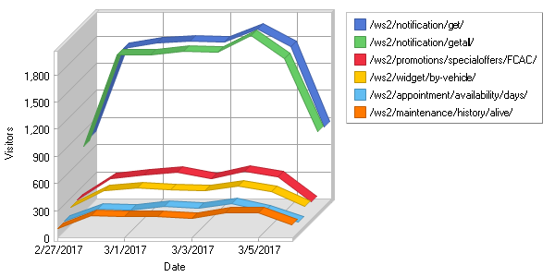

**Most Requested Directories**  
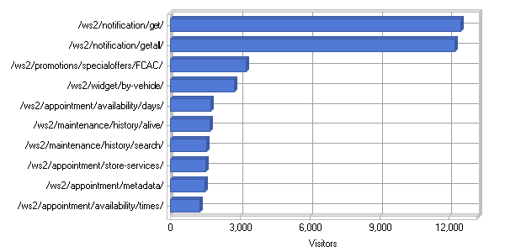

**Most Requested Directories**

|  |
| --- |
|  |

|  |  |  |  |  |  |  |  |  |  |  |  |  |  |  |  |  |  |  |  |  |  |  |  |  |  |  |  |  |  |  |  |  |  |  |  |  |  |  |  |  |  |  |  |  |  |  |  |  |  |  |  |  |  |  |  |  |  |  |  |  |  |  |  |  |  |  |  |  |  |  |  |  |  |  |  |  |  |  |  |  |  |  |  |  |  |  |  |  |  |  |  |  |  |  |  |  |  |  |  |  |  |  |  |  |  |  |  |  |  |  |  |  |  |  |  |  |  |  |  |  |  |  |  |  |  |  |  |  |  |  |  |  |  |  |  |  |  |  |  |  |  |  |  |  |  |  |  |  |  |  |  |  |  |  |  |  |  |  |  |  |  |  |  |  |  |  |  |  |  |  |  |  |  |  |  |  |  |  |  |  |  |  |  |  |  |  |  |  |  |  |  |  |  |  |  |  |  |  |  |  |  |  |  |  |  |  |  |  |  |  |  |  |  |  |  |  |  |  |  |  |  |  |  |  |  |  |  |  |  |  |  |  |  |  |  |  |  |  |  |  |  |  |  |  |  |  |  |  |  |  |  |  |  |  |  |  |  |  |  |  |  |  |  |  |  |  |  |  |  |  |  |  |  |  |  |  |  |  |  |  |  |  |  |  |  |  |  |  |  |  |  |  |  |  |  |  |  |  |  |  |  |  |  |  |  |  |  |  |  |  |  |  |  |  |  |  |  |  |
| --- | --- | --- | --- | --- | --- | --- | --- | --- | --- | --- | --- | --- | --- | --- | --- | --- | --- | --- | --- | --- | --- | --- | --- | --- | --- | --- | --- | --- | --- | --- | --- | --- | --- | --- | --- | --- | --- | --- | --- | --- | --- | --- | --- | --- | --- | --- | --- | --- | --- | --- | --- | --- | --- | --- | --- | --- | --- | --- | --- | --- | --- | --- | --- | --- | --- | --- | --- | --- | --- | --- | --- | --- | --- | --- | --- | --- | --- | --- | --- | --- | --- | --- | --- | --- | --- | --- | --- | --- | --- | --- | --- | --- | --- | --- | --- | --- | --- | --- | --- | --- | --- | --- | --- | --- | --- | --- | --- | --- | --- | --- | --- | --- | --- | --- | --- | --- | --- | --- | --- | --- | --- | --- | --- | --- | --- | --- | --- | --- | --- | --- | --- | --- | --- | --- | --- | --- | --- | --- | --- | --- | --- | --- | --- | --- | --- | --- | --- | --- | --- | --- | --- | --- | --- | --- | --- | --- | --- | --- | --- | --- | --- | --- | --- | --- | --- | --- | --- | --- | --- | --- | --- | --- | --- | --- | --- | --- | --- | --- | --- | --- | --- | --- | --- | --- | --- | --- | --- | --- | --- | --- | --- | --- | --- | --- | --- | --- | --- | --- | --- | --- | --- | --- | --- | --- | --- | --- | --- | --- | --- | --- | --- | --- | --- | --- | --- | --- | --- | --- | --- | --- | --- | --- | --- | --- | --- | --- | --- | --- | --- | --- | --- | --- | --- | --- | --- | --- | --- | --- | --- | --- | --- | --- | --- | --- | --- | --- | --- | --- | --- | --- | --- | --- | --- | --- | --- | --- | --- | --- | --- | --- | --- | --- | --- | --- | --- | --- | --- | --- | --- | --- | --- | --- | --- | --- | --- | --- | --- | --- | --- | --- | --- | --- | --- | --- | --- | --- | --- | --- | --- | --- | --- | --- | --- | --- | --- | --- | --- | --- | --- | --- | --- | --- | --- | --- | --- | --- | --- | --- | --- | --- | --- | --- | --- | --- | --- | --- | --- | --- |
| |  |  |  |  |  |  | | --- | --- | --- | --- | --- | --- | |  | **Directory** | **Hits** | **Incomplete Requests** | **Visitors** | **Bandwidth (KB)** | | 1 | [http://www.api-aem.bsro.com/ ws2/notification/get/](http://www.api-aem.bsro.com/ws2/notification/get/) | 14,834 | 0 | 12,493 | 1,314 | | 2 | [http://www.api-aem.bsro.com/ ws2/notification/getall/](http://www.api-aem.bsro.com/ws2/notification/getall/) | 14,159 | 0 | 12,249 | 1,261 | | 3 | [http://www.api-aem.bsro.com/ ws2/promotions/specialoffers/ FCAC/](http://www.api-aem.bsro.com/ws2/promotions/specialoffers/FCAC/) | 16,531 | 0 | 3,250 | 36,077 | | 4 | [http://www.api-aem.bsro.com/ ws2/widget/by-vehicle/](http://www.api-aem.bsro.com/ws2/widget/by-vehicle/) | 3,523 | 0 | 2,754 | 752 | | 5 | [http://www.api-aem.bsro.com/ ws2/appointment/availability/ days/](http://www.api-aem.bsro.com/ws2/appointment/availability/days/) | 50,052 | 0 | 1,756 | 150,890 | | 6 | [http://www.api-aem.bsro.com/ ws2/maintenance/history/ alive/](http://www.api-aem.bsro.com/ws2/maintenance/history/alive/) | 2,244 | 0 | 1,702 | 26 | | 7 | [http://www.api-aem.bsro.com/ ws2/maintenance/history/ search/](http://www.api-aem.bsro.com/ws2/maintenance/history/search/) | 2,018 | 0 | 1,558 | 21,881 | | 8 | [http://www.api-aem.bsro.com/ ws2/appointment/store-services/](http://www.api-aem.bsro.com/ws2/appointment/store-services/) | 37,049 | 0 | 1,526 | 90,441 | | 9 | [http://www.api-aem.bsro.com/ ws2/appointment/metadata/](http://www.api-aem.bsro.com/ws2/appointment/metadata/) | 48,148 | 0 | 1,500 | 8,205 | | 10 | [http://www.api-aem.bsro.com/ ws2/appointment/availability/ times/](http://www.api-aem.bsro.com/ws2/appointment/availability/times/) | 114,857 | 0 | 1,285 | 38,652 | | 11 | [http://www.api-aem.bsro.com/ ws2/store/info/](http://www.api-aem.bsro.com/ws2/store/info/) | 198,075 | 0 | 899 | 212,926 | | 12 | [http://www.api-aem.bsro.com/ ws2/appointment/book/](http://www.api-aem.bsro.com/ws2/appointment/book/) | 11,540 | 0 | 800 | 3,282 | | 13 | [http://www.api-aem.bsro.com/ ws2/promotions/specialoffers/TP/](http://www.api-aem.bsro.com/ws2/promotions/specialoffers/TP/) | 7,608 | 0 | 739 | 17,475 | | 14 | [http://www.api-aem.bsro.com/ ws2/mobile-app-user/authenticate/](http://www.api-aem.bsro.com/ws2/mobile-app-user/authenticate/) | 774 | 0 | 501 | 32 | | 15 | [http://www.api-aem.bsro.com/ ws2/widget/by-vehicle/ 2007/](http://www.api-aem.bsro.com/ws2/widget/by-vehicle/2007/) | 14,341 | 0 | 410 | 39,657 | | 16 | [http://www.api-aem.bsro.com/ ws2/widget/by-vehicle/ 2012/](http://www.api-aem.bsro.com/ws2/widget/by-vehicle/2012/) | 15,924 | 0 | 396 | 43,992 | | 17 | [http://www.api-aem.bsro.com/ ws2/widget/by-vehicle/ 2013/](http://www.api-aem.bsro.com/ws2/widget/by-vehicle/2013/) | 16,890 | 0 | 395 | 44,769 | | 18 | [http://www.api-aem.bsro.com/ ws2/widget/by-vehicle/ 2008/](http://www.api-aem.bsro.com/ws2/widget/by-vehicle/2008/) | 14,665 | 0 | 388 | 41,534 | | 19 | [http://www.api-aem.bsro.com/ ws2/widget/by-vehicle/ 2006/](http://www.api-aem.bsro.com/ws2/widget/by-vehicle/2006/) | 13,552 | 0 | 373 | 38,276 | | 20 | [http://www.api-aem.bsro.com/ ws2/widget/by-vehicle/ 2010/](http://www.api-aem.bsro.com/ws2/widget/by-vehicle/2010/) | 13,225 | 0 | 373 | 35,945 | | 21 | [http://www.api-aem.bsro.com/ ws2/widget/by-vehicle/ 2011/](http://www.api-aem.bsro.com/ws2/widget/by-vehicle/2011/) | 14,434 | 0 | 367 | 38,315 | | 22 | [http://www.api-aem.bsro.com/ ws2/widget/by-vehicle/ 2004/](http://www.api-aem.bsro.com/ws2/widget/by-vehicle/2004/) | 12,258 | 0 | 358 | 34,689 | | 23 | [http://www.api-aem.bsro.com/ ws2/widget/by-vehicle/ 2005/](http://www.api-aem.bsro.com/ws2/widget/by-vehicle/2005/) | 13,371 | 0 | 354 | 37,045 | | 24 | [http://www.api-aem.bsro.com/ ws2/widget/by-vehicle/ 2014/](http://www.api-aem.bsro.com/ws2/widget/by-vehicle/2014/) | 17,572 | 0 | 351 | 46,186 | | 25 | [http://www.api-aem.bsro.com/ ws2/widget/by-vehicle/ 2015/](http://www.api-aem.bsro.com/ws2/widget/by-vehicle/2015/) | 16,119 | 0 | 345 | 41,678 | | 26 | [http://www.api-aem.bsro.com/ ws2/notification/update/](http://www.api-aem.bsro.com/ws2/notification/update/) | 579 | 0 | 343 | 33 | | 27 | [http://www.api-aem.bsro.com/ ws2/widget/by-vehicle/ 2009/](http://www.api-aem.bsro.com/ws2/widget/by-vehicle/2009/) | 12,070 | 0 | 338 | 32,806 | | 28 | [http://www.api-aem.bsro.com/ ws2/widget/by-vehicle/ 2003/](http://www.api-aem.bsro.com/ws2/widget/by-vehicle/2003/) | 11,237 | 0 | 315 | 30,510 | | 29 | [http://www.api-aem.bsro.com/ ws2/widget/by-vehicle/ 2002/](http://www.api-aem.bsro.com/ws2/widget/by-vehicle/2002/) | 10,597 | 0 | 313 | 29,447 | | 30 | [http://www.api-aem.bsro.com/ ws2/widget/by-vehicle/ 2016/](http://www.api-aem.bsro.com/ws2/widget/by-vehicle/2016/) | 13,545 | 0 | 296 | 34,307 | | 31 | [http://www.api-aem.bsro.com/ ws2/widget/by-vehicle/ 2000/](http://www.api-aem.bsro.com/ws2/widget/by-vehicle/2000/) | 8,671 | 0 | 273 | 22,227 | | 32 | [http://www.api-aem.bsro.com/ ws2/widget/by-vehicle/ 2001/](http://www.api-aem.bsro.com/ws2/widget/by-vehicle/2001/) | 9,207 | 0 | 270 | 24,092 | | 33 | [http://www.api-aem.bsro.com/ ws2/store/locator/zip/ 60605/FCAC/](http://www.api-aem.bsro.com/ws2/store/locator/zip/60605/FCAC/) | 827 | 0 | 268 | 10,912 | | 34 | [http://www.api-aem.bsro.com/ ws2/store/locator/address/ FCAC/](http://www.api-aem.bsro.com/ws2/store/locator/address/FCAC/) | 15,297 | 0 | 266 | 368,422 | | 35 | [http://www.api-aem.bsro.com/ ws2/widget/by-vehicle/ 1999/](http://www.api-aem.bsro.com/ws2/widget/by-vehicle/1999/) | 7,797 | 0 | 261 | 19,482 | | 36 | [http://www.api-aem.bsro.com/ ws2/widget/by-vehicle/ 2017/](http://www.api-aem.bsro.com/ws2/widget/by-vehicle/2017/) | 5,994 | 0 | 254 | 11,522 | | 37 | [http://www.api-aem.bsro.com/ ws2/widget/by-vehicle/ 1998/](http://www.api-aem.bsro.com/ws2/widget/by-vehicle/1998/) | 6,830 | 0 | 253 | 17,127 | | 38 | [http://www.api-aem.bsro.com/ ws2/mobile-app-user/register/](http://www.api-aem.bsro.com/ws2/mobile-app-user/register/) | 241 | 0 | 238 | 11 | | 39 | [http://www.api-aem.bsro.com/ ws2/widget/by-vehicle/ 1997/](http://www.api-aem.bsro.com/ws2/widget/by-vehicle/1997/) | 6,580 | 0 | 236 | 16,853 | | 40 | [http://www.api-aem.bsro.com/ ws2/mobile-app-user/check-data/](http://www.api-aem.bsro.com/ws2/mobile-app-user/check-data/) | 271 | 0 | 229 | 10 | | 41 | [http://www.api-aem.bsro.com/ ws2/widget/by-vehicle/ 1996/](http://www.api-aem.bsro.com/ws2/widget/by-vehicle/1996/) | 5,845 | 0 | 228 | 14,271 | | 42 | [http://www.api-aem.bsro.com/ ws2/promotions/specialoffers/HT/](http://www.api-aem.bsro.com/ws2/promotions/specialoffers/HT/) | 3,343 | 0 | 223 | 9,621 | | 43 | [http://www.api-aem.bsro.com/ ws2/promotions/specialoffers/WWT/](http://www.api-aem.bsro.com/ws2/promotions/specialoffers/WWT/) | 3,197 | 0 | 223 | 9,875 | | 44 | [http://www.api-aem.bsro.com/ ws2/ipinfo/ip/](http://www.api-aem.bsro.com/ws2/ipinfo/ip/) | 570,137 | 0 | 222 | 40,032 | | 45 | [http://www.api-aem.bsro.com/ ws2/widget/by-vehicle/ 1995/](http://www.api-aem.bsro.com/ws2/widget/by-vehicle/1995/) | 5,999 | 0 | 222 | 15,355 | | 46 | [http://www.api-aem.bsro.com/ ws2/widget/by-vehicle/ 1994/](http://www.api-aem.bsro.com/ws2/widget/by-vehicle/1994/) | 5,455 | 0 | 215 | 14,325 | | 47 | [http://www.api-aem.bsro.com/ ws2/store/services/](http://www.api-aem.bsro.com/ws2/store/services/) | 134,295 | 0 | 210 | 21,254 | | 48 | [http://www.api-aem.bsro.com/ ws2/vehicle/tire/repair-alignment-pricing/get/](http://www.api-aem.bsro.com/ws2/vehicle/tire/repair-alignment-pricing/get/) | 6,558 | 0 | 209 | 2,065 | | 49 | [http://www.api-aem.bsro.com/ ws2/tires/quote/get/](http://www.api-aem.bsro.com/ws2/tires/quote/get/) | 59,629 | 0 | 209 | 739,178 | | 50 | [http://www.api-aem.bsro.com/ ws2/tires/all-tires/FCAC/](http://www.api-aem.bsro.com/ws2/tires/all-tires/FCAC/) | 31,306 | 0 | 208 | 1,383,136 | |  | **Subtotal** | **1,619,270** | **0** | **N/A** | **3,892,198** | |  | **Total** | **5,200,685** | **0** | **N/A** | **13,269,588** | |

|  |  |  |
| --- | --- | --- |
| C:\ProgramData\WebLog Expert Lite\Report\index_files\section_left.gif | **Entry Pages** | C:\ProgramData\WebLog Expert Lite\Report\index_files\section_right.gif |

**Daily Entry Pages**  
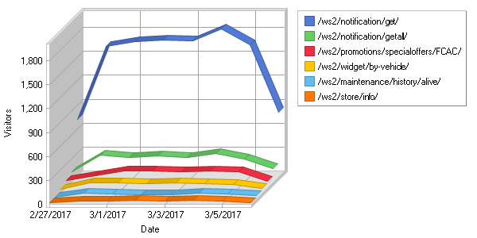

**Top Entry Pages**  
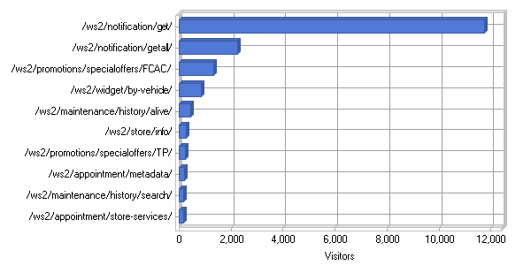

**Top Entry Pages**

|  |
| --- |
|  |

|  |  |  |  |  |  |  |  |  |  |  |  |  |  |  |  |  |  |  |  |  |  |  |  |  |  |  |  |  |  |  |  |  |  |  |  |  |  |  |  |  |  |  |  |  |  |  |  |  |  |  |  |  |  |  |  |  |  |  |  |  |  |  |  |  |  |  |  |  |  |  |  |  |  |  |  |  |  |  |  |  |  |  |  |  |  |  |  |  |  |  |  |  |  |  |  |  |  |  |  |  |  |  |  |  |  |  |  |  |  |  |  |  |  |  |  |  |  |  |  |  |  |  |  |  |  |  |  |  |  |  |  |  |  |  |  |  |  |  |  |  |  |  |  |  |  |  |  |  |  |  |  |  |  |  |  |  |  |  |  |
| --- | --- | --- | --- | --- | --- | --- | --- | --- | --- | --- | --- | --- | --- | --- | --- | --- | --- | --- | --- | --- | --- | --- | --- | --- | --- | --- | --- | --- | --- | --- | --- | --- | --- | --- | --- | --- | --- | --- | --- | --- | --- | --- | --- | --- | --- | --- | --- | --- | --- | --- | --- | --- | --- | --- | --- | --- | --- | --- | --- | --- | --- | --- | --- | --- | --- | --- | --- | --- | --- | --- | --- | --- | --- | --- | --- | --- | --- | --- | --- | --- | --- | --- | --- | --- | --- | --- | --- | --- | --- | --- | --- | --- | --- | --- | --- | --- | --- | --- | --- | --- | --- | --- | --- | --- | --- | --- | --- | --- | --- | --- | --- | --- | --- | --- | --- | --- | --- | --- | --- | --- | --- | --- | --- | --- | --- | --- | --- | --- | --- | --- | --- | --- | --- | --- | --- | --- | --- | --- | --- | --- | --- | --- | --- | --- | --- | --- | --- | --- | --- | --- | --- | --- | --- | --- | --- | --- | --- | --- | --- |
| |  |  |  | | --- | --- | --- | |  | **Page** | **Visitors** | | 1 | [http://www.api-aem.bsro.com/ ws2/notification/get/](http://www.api-aem.bsro.com/ws2/notification/get/) | 11,764 | | 2 | [http://www.api-aem.bsro.com/ ws2/notification/getall/](http://www.api-aem.bsro.com/ws2/notification/getall/) | 2,235 | | 3 | [http://www.api-aem.bsro.com/ ws2/promotions/specialoffers/ FCAC/](http://www.api-aem.bsro.com/ws2/promotions/specialoffers/FCAC/) | 1,342 | | 4 | [http://www.api-aem.bsro.com/ ws2/widget/by-vehicle/](http://www.api-aem.bsro.com/ws2/widget/by-vehicle/) | 862 | | 5 | [http://www.api-aem.bsro.com/ ws2/maintenance/history/ alive/](http://www.api-aem.bsro.com/ws2/maintenance/history/alive/) | 431 | | 6 | [http://www.api-aem.bsro.com/ ws2/store/info/](http://www.api-aem.bsro.com/ws2/store/info/) | 288 | | 7 | [http://www.api-aem.bsro.com/ ws2/promotions/specialoffers/TP/](http://www.api-aem.bsro.com/ws2/promotions/specialoffers/TP/) | 232 | | 8 | [http://www.api-aem.bsro.com/ ws2/appointment/metadata/](http://www.api-aem.bsro.com/ws2/appointment/metadata/) | 209 | | 9 | [http://www.api-aem.bsro.com/ ws2/maintenance/history/ search/](http://www.api-aem.bsro.com/ws2/maintenance/history/search/) | 167 | | 10 | [http://www.api-aem.bsro.com/ ws2/appointment/store-services/](http://www.api-aem.bsro.com/ws2/appointment/store-services/) | 155 | | 11 | [http://www.api-aem.bsro.com/ ws2/mobile-app-user/authenticate/](http://www.api-aem.bsro.com/ws2/mobile-app-user/authenticate/) | 119 | | 12 | [http://www.api-aem.bsro.com/ ws2/contact/save-wifi-contact/](http://www.api-aem.bsro.com/ws2/contact/save-wifi-contact/) | 89 | | 13 | [http://www.api-aem.bsro.com/ ws2/notification/update/](http://www.api-aem.bsro.com/ws2/notification/update/) | 84 | | 14 | [http://www.api-aem.bsro.com/ ws2/appointment/availability/ days/](http://www.api-aem.bsro.com/ws2/appointment/availability/days/) | 71 | | 15 | [http://www.api-aem.bsro.com/ ws2/ipinfo/ip/](http://www.api-aem.bsro.com/ws2/ipinfo/ip/) | 38 | | 16 | [http://www.api-aem.bsro.com/ ws2/store/locator/zip/ 18540/FCAC/](http://www.api-aem.bsro.com/ws2/store/locator/zip/18540/FCAC/) | 34 | | 17 | [http://www.api-aem.bsro.com/ ws2/store/locator/address/ FCAC/](http://www.api-aem.bsro.com/ws2/store/locator/address/FCAC/) | 31 | | 18 | [http://www.api-aem.bsro.com/ ws2/appointment/availability/ times/](http://www.api-aem.bsro.com/ws2/appointment/availability/times/) | 30 | | 19 | <http://www.api-aem.bsro.com/> | 28 | | 20 | [http://www.api-aem.bsro.com/ ws2/mobile-app-user/forgot-password/](http://www.api-aem.bsro.com/ws2/mobile-app-user/forgot-password/) | 27 | | 21 | [http://www.api-aem.bsro.com/ ws2/mobile-app-user/register/](http://www.api-aem.bsro.com/ws2/mobile-app-user/register/) | 27 | | 22 | [http://www.api-aem.bsro.com/ ws2/store/locator/zip/ 60605/FCAC/](http://www.api-aem.bsro.com/ws2/store/locator/zip/60605/FCAC/) | 24 | | 23 | [http://www.api-aem.bsro.com/ ws2/appointment/book/](http://www.api-aem.bsro.com/ws2/appointment/book/) | 21 | | 24 | [http://www.api-aem.bsro.com/ ws2/widget/by-vehicle/ 2007/](http://www.api-aem.bsro.com/ws2/widget/by-vehicle/2007/) | 15 | | 25 | [http://www.api-aem.bsro.com/ ws2/tires/pricing/results/](http://www.api-aem.bsro.com/ws2/tires/pricing/results/) | 14 | | 26 | [http://www.api-aem.bsro.com/ ws2/widget/by-vehicle/ 2011/](http://www.api-aem.bsro.com/ws2/widget/by-vehicle/2011/) | 14 | | 27 | [http://www.api-aem.bsro.com/ ws2/widget/by-vehicle/ 2010/](http://www.api-aem.bsro.com/ws2/widget/by-vehicle/2010/) | 14 | | 28 | [http://www.api-aem.bsro.com/ ws2/widget/by-vehicle/ 2004/](http://www.api-aem.bsro.com/ws2/widget/by-vehicle/2004/) | 13 | | 29 | [http://www.api-aem.bsro.com/ ws2/widget/by-vehicle/ 2013/](http://www.api-aem.bsro.com/ws2/widget/by-vehicle/2013/) | 12 | | 30 | [http://www.api-aem.bsro.com/ ws2/widget/by-vehicle/ 2006/](http://www.api-aem.bsro.com/ws2/widget/by-vehicle/2006/) | 12 | | 31 | [http://www.api-aem.bsro.com/ ws2/widget/by-vehicle/ 2005/](http://www.api-aem.bsro.com/ws2/widget/by-vehicle/2005/) | 12 | | 32 | [http://www.api-aem.bsro.com/ ws2/widget/by-vehicle/ 2003/](http://www.api-aem.bsro.com/ws2/widget/by-vehicle/2003/) | 10 | | 33 | [http://www.api-aem.bsro.com/ ws2/widget/by-vehicle/ 2008/](http://www.api-aem.bsro.com/ws2/widget/by-vehicle/2008/) | 10 | | 34 | [http://www.api-aem.bsro.com/ ws2/widget/by-vehicle/ 2012/](http://www.api-aem.bsro.com/ws2/widget/by-vehicle/2012/) | 9 | | 35 | [http://www.api-aem.bsro.com/ ws2/widget/by-vehicle/ 2014/](http://www.api-aem.bsro.com/ws2/widget/by-vehicle/2014/) | 9 | | 36 | [http://www.api-aem.bsro.com/ ws2/widget/by-vehicle/ 2009/](http://www.api-aem.bsro.com/ws2/widget/by-vehicle/2009/) | 8 | | 37 | [http://www.api-aem.bsro.com/ ws2/widget/by-vehicle/ 2015/](http://www.api-aem.bsro.com/ws2/widget/by-vehicle/2015/) | 8 | | 38 | [http://www.api-aem.bsro.com/ ws2/widget/by-vehicle/ 2016/](http://www.api-aem.bsro.com/ws2/widget/by-vehicle/2016/) | 7 | | 39 | [http://www.api-aem.bsro.com/ ws2/widget/by-vehicle/ 2000/](http://www.api-aem.bsro.com/ws2/widget/by-vehicle/2000/) | 7 | | 40 | [http://www.api-aem.bsro.com/ ws2/store/info/FCAC-MVAN/](http://www.api-aem.bsro.com/ws2/store/info/FCAC-MVAN/) | 7 | | 41 | [http://www.api-aem.bsro.com/ ws2/mobile-app-user/backup/](http://www.api-aem.bsro.com/ws2/mobile-app-user/backup/) | 6 | | 42 | [http://www.api-aem.bsro.com/ ws2/widget/by-vehicle/ 2002/](http://www.api-aem.bsro.com/ws2/widget/by-vehicle/2002/) | 6 | | 43 | [http://www.api-aem.bsro.com/ ws2/store/services/](http://www.api-aem.bsro.com/ws2/store/services/) | 6 | | 44 | [http://www.api-aem.bsro.com/ ws2/notification/delete/](http://www.api-aem.bsro.com/ws2/notification/delete/) | 4 | | 45 | [http://www.api-aem.bsro.com/ ws2/widget/by-vehicle/ 2017/](http://www.api-aem.bsro.com/ws2/widget/by-vehicle/2017/) | 4 | | 46 | [http://www.api-aem.bsro.com/ ws2/widget/by-vehicle/ 1996/](http://www.api-aem.bsro.com/ws2/widget/by-vehicle/1996/) | 4 | | 47 | [http://www.api-aem.bsro.com/ ws2/widget/by-vehicle/ 2001/](http://www.api-aem.bsro.com/ws2/widget/by-vehicle/2001/) | 4 | | 48 | [http://www.api-aem.bsro.com/ ws2/maintenance/scheduled/ categories/156313/](http://www.api-aem.bsro.com/ws2/maintenance/scheduled/categories/156313/) | 4 | | 49 | [http://www.api-aem.bsro.com/ ws2/widget/by-vehicle/ 2007/47/](http://www.api-aem.bsro.com/ws2/widget/by-vehicle/2007/47/) | 3 | | 50 | [http://www.api-aem.bsro.com/ ws2/store/locator/address/TP/](http://www.api-aem.bsro.com/ws2/store/locator/address/TP/) | 3 | |  | **Subtotal** | **18,533** | |  | **Total** | **19,778** | |

|  |  |  |
| --- | --- | --- |
| C:\ProgramData\WebLog Expert Lite\Report\index_files\section_left.gif | **Hosts** | C:\ProgramData\WebLog Expert Lite\Report\index_files\section_right.gif |

**Top Hosts**

|  |
| --- |
|  |

|  |  |  |  |  |  |  |  |  |  |  |  |  |  |  |  |  |  |  |  |  |  |  |  |  |  |  |  |  |  |  |  |  |  |  |  |  |  |  |  |  |  |  |  |  |  |  |  |  |  |  |  |  |  |  |  |  |  |  |  |  |  |  |  |  |  |  |  |  |  |  |  |  |  |  |  |  |  |  |  |  |  |  |  |  |  |  |  |  |  |  |  |  |  |  |  |  |  |  |  |  |  |  |  |  |  |  |  |  |  |  |  |  |  |  |  |  |  |  |  |  |  |  |  |  |  |  |  |  |  |  |  |  |  |  |  |  |  |  |  |  |  |  |  |  |  |  |  |  |  |  |  |  |  |  |  |  |  |  |  |  |  |  |  |  |  |  |  |  |  |  |  |  |  |  |  |  |  |  |  |  |  |  |  |  |  |  |  |  |  |  |  |  |  |  |  |  |  |  |  |  |  |  |  |  |  |  |  |  |  |  |  |  |  |  |  |  |  |  |  |  |  |  |  |  |  |  |  |  |  |  |  |  |  |  |  |  |  |  |  |  |  |  |  |  |  |  |  |  |  |  |  |  |  |  |  |  |  |  |  |  |  |  |  |  |  |
| --- | --- | --- | --- | --- | --- | --- | --- | --- | --- | --- | --- | --- | --- | --- | --- | --- | --- | --- | --- | --- | --- | --- | --- | --- | --- | --- | --- | --- | --- | --- | --- | --- | --- | --- | --- | --- | --- | --- | --- | --- | --- | --- | --- | --- | --- | --- | --- | --- | --- | --- | --- | --- | --- | --- | --- | --- | --- | --- | --- | --- | --- | --- | --- | --- | --- | --- | --- | --- | --- | --- | --- | --- | --- | --- | --- | --- | --- | --- | --- | --- | --- | --- | --- | --- | --- | --- | --- | --- | --- | --- | --- | --- | --- | --- | --- | --- | --- | --- | --- | --- | --- | --- | --- | --- | --- | --- | --- | --- | --- | --- | --- | --- | --- | --- | --- | --- | --- | --- | --- | --- | --- | --- | --- | --- | --- | --- | --- | --- | --- | --- | --- | --- | --- | --- | --- | --- | --- | --- | --- | --- | --- | --- | --- | --- | --- | --- | --- | --- | --- | --- | --- | --- | --- | --- | --- | --- | --- | --- | --- | --- | --- | --- | --- | --- | --- | --- | --- | --- | --- | --- | --- | --- | --- | --- | --- | --- | --- | --- | --- | --- | --- | --- | --- | --- | --- | --- | --- | --- | --- | --- | --- | --- | --- | --- | --- | --- | --- | --- | --- | --- | --- | --- | --- | --- | --- | --- | --- | --- | --- | --- | --- | --- | --- | --- | --- | --- | --- | --- | --- | --- | --- | --- | --- | --- | --- | --- | --- | --- | --- | --- | --- | --- | --- | --- | --- | --- | --- | --- | --- | --- | --- | --- | --- | --- | --- | --- | --- | --- | --- | --- | --- | --- | --- | --- | --- | --- | --- | --- | --- | --- | --- | --- | --- | --- | --- |
| |  |  |  |  |  | | --- | --- | --- | --- | --- | |  | **Host** | **Hits** | **Visitors** | **Bandwidth (KB)** | | 1 | 52.22.86.170 | 5,179,398 | 208 | 13,171,629 | | 2 | 52.23.115.213 | 474 | 159 | 786 | | 3 | 63.137.180.3 | 505 | 73 | 80 | | 4 | 54.83.58.21 | 1,007 | 31 | 0 | | 5 | 96.126.120.145 | 970 | 29 | 0 | | 6 | 50.116.43.60 | 990 | 26 | 0 | | 7 | 50.18.110.134 | 981 | 26 | 0 | | 8 | 66.175.216.150 | 1,023 | 22 | 0 | | 9 | 121.244.41.21 | 114 | 21 | 5,547 | | 10 | 66.175.209.119 | 1,022 | 20 | 0 | | 11 | 59.144.135.7 | 233 | 20 | 1,468 | | 12 | 54.214.23.0 | 1,017 | 19 | 0 | | 13 | 199.48.25.10 | 66 | 11 | 84 | | 14 | 76.125.221.193 | 51 | 10 | 31 | | 15 | 174.193.147.86 | 21 | 9 | 1 | | 16 | 75.128.254.91 | 38 | 9 | 94 | | 17 | 52.5.157.25 | 92 | 9 | 1,277 | | 18 | 207.45.156.253 | 25 | 9 | 54 | | 19 | 107.77.161.4 | 33 | 8 | 12 | | 20 | 73.176.24.154 | 48 | 8 | 94 | | 21 | 107.77.237.112 | 31 | 7 | 53 | | 22 | 23.112.66.184 | 15 | 7 | 1 | | 23 | 74.66.228.24 | 27 | 7 | 81 | | 24 | 198.101.252.8 | 8 | 7 | 14,646 | | 25 | 74.96.163.194 | 19 | 7 | 9 | | 26 | 166.137.126.30 | 16 | 7 | 1 | | 27 | 70.196.2.73 | 15 | 7 | 4 | | 28 | 174.238.14.167 | 27 | 7 | 8 | | 29 | 70.211.16.236 | 13 | 6 | 7 | | 30 | 216.231.193.37 | 28 | 6 | 19 | | 31 | 166.137.139.112 | 21 | 6 | 8 | | 32 | 72.180.169.181 | 15 | 6 | 46 | | 33 | 68.102.57.21 | 21 | 6 | 3 | | 34 | 108.22.89.123 | 46 | 6 | 11 | | 35 | 97.85.188.48 | 18 | 6 | 5 | | 36 | 130.211.176.107 | 10 | 6 | 1,542 | | 37 | 107.72.164.111 | 9 | 6 | 0 | | 38 | 107.77.94.29 | 13 | 6 | 34 | | 39 | 73.252.152.166 | 32 | 6 | 32 | | 40 | 64.244.196.199 | 23 | 6 | 339 | | 41 | 107.143.74.144 | 43 | 6 | 8 | | 42 | 73.16.235.34 | 48 | 5 | 101 | | 43 | 166.137.240.95 | 21 | 5 | 5 | | 44 | 70.175.116.231 | 9 | 5 | 2 | | 45 | 107.77.161.10 | 27 | 5 | 2 | | 46 | 172.56.30.152 | 31 | 5 | 17 | | 47 | 73.197.39.153 | 26 | 5 | 13 | | 48 | 172.56.11.138 | 7 | 5 | 0 | | 49 | 107.2.58.199 | 7 | 5 | 0 | | 50 | 24.140.100.214 | 10 | 5 | 2 | |  | **Subtotal** | **5,188,744** | **906** | **13,198,182** | |  | **Total** | **5,288,298** | **20,226** | **13,284,980** | |

|  |  |  |
| --- | --- | --- |
| C:\ProgramData\WebLog Expert Lite\Report\index_files\section_left.gif | **Referring Sites** | C:\ProgramData\WebLog Expert Lite\Report\index_files\section_right.gif |

**Daily Referring Sites**  
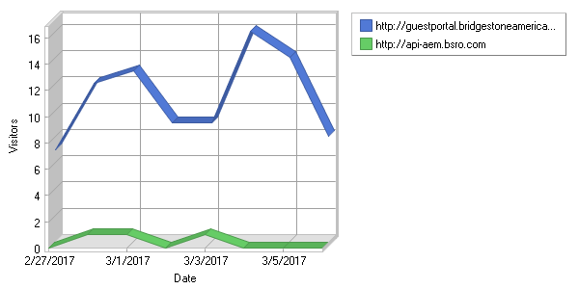

**Top Referring Sites**  
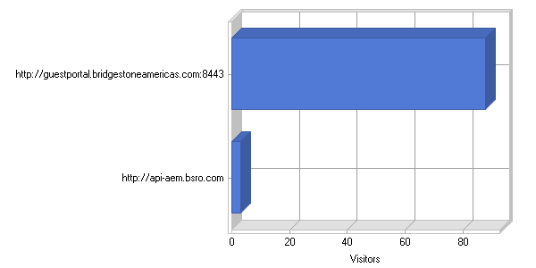

**Top Referring Sites**

|  |
| --- |
|  |

|  |  |  |  |  |  |  |  |  |  |  |  |  |  |  |  |
| --- | --- | --- | --- | --- | --- | --- | --- | --- | --- | --- | --- | --- | --- | --- | --- |
| |  |  |  | | --- | --- | --- | |  | **Site** | **Visitors** | | 1 | No Referrer | 20,134 | | 2 | [http://guestportal.bridgestoneamericas.com:8443](http://guestportal.bridgestoneamericas.com:8443/) | 88 | | 3 | [http://api-aem.bsro.com](http://api-aem.bsro.com/) | 3 | |  | **Total** | **20,225** | |

|  |  |  |
| --- | --- | --- |
| C:\ProgramData\WebLog Expert Lite\Report\index_files\section_left.gif | **Referring URLs** | C:\ProgramData\WebLog Expert Lite\Report\index_files\section_right.gif |

**Daily Referring URLs**  
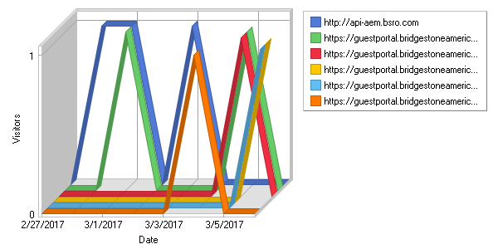

**Top Referring URLs**  
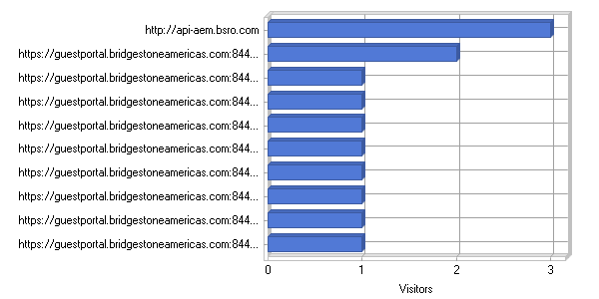

**Top Referring URLs**

|  |
| --- |
|  |

|  |  |  |  |  |  |  |  |  |  |  |  |  |  |  |  |  |  |  |  |  |  |  |  |  |  |  |  |  |  |  |  |  |  |  |  |  |  |  |  |  |  |  |  |  |  |  |  |  |  |  |  |  |  |  |  |  |  |  |  |  |  |  |  |  |  |  |  |  |  |  |  |  |  |  |  |  |  |  |  |  |  |  |  |  |  |  |  |  |  |  |  |  |  |  |  |  |  |  |  |  |  |  |  |  |  |  |  |  |  |  |  |  |  |  |  |  |  |  |  |  |  |  |  |  |  |  |  |  |  |  |  |  |  |  |  |  |  |  |  |  |  |  |  |  |  |  |  |  |  |  |  |  |  |  |  |  |  |  |  |  |  |
| --- | --- | --- | --- | --- | --- | --- | --- | --- | --- | --- | --- | --- | --- | --- | --- | --- | --- | --- | --- | --- | --- | --- | --- | --- | --- | --- | --- | --- | --- | --- | --- | --- | --- | --- | --- | --- | --- | --- | --- | --- | --- | --- | --- | --- | --- | --- | --- | --- | --- | --- | --- | --- | --- | --- | --- | --- | --- | --- | --- | --- | --- | --- | --- | --- | --- | --- | --- | --- | --- | --- | --- | --- | --- | --- | --- | --- | --- | --- | --- | --- | --- | --- | --- | --- | --- | --- | --- | --- | --- | --- | --- | --- | --- | --- | --- | --- | --- | --- | --- | --- | --- | --- | --- | --- | --- | --- | --- | --- | --- | --- | --- | --- | --- | --- | --- | --- | --- | --- | --- | --- | --- | --- | --- | --- | --- | --- | --- | --- | --- | --- | --- | --- | --- | --- | --- | --- | --- | --- | --- | --- | --- | --- | --- | --- | --- | --- | --- | --- | --- | --- | --- | --- | --- | --- | --- | --- | --- | --- | --- | --- | --- |
| |  |  |  | | --- | --- | --- | |  | **URL** | **Visitors** | | 1 | No Referrer | 20,134 | | 2 | [http://api-aem.bsro.com](http://api-aem.bsro.com/) | 3 | | 3 | [https://guestportal.bridgestoneamericas.com:8443/ guestportal/portals/FirestonePortal/ success.html](https://guestportal.bridgestoneamericas.com:8443/guestportal/portals/FirestonePortal/success.html) | 2 | | 4 | [https://guestportal.bridgestoneamericas.com:8443/ guestportal/Login.action? portalname=TiresPlusPortal& sessionId=c200710a01a42e07d055bc58](https://guestportal.bridgestoneamericas.com:8443/guestportal/Login.action?portalname=TiresPlusPortal&sessionId=c200710a01a42e07d055bc58) | 1 | | 5 | [https://guestportal.bridgestoneamericas.com:8443/ guestportal/Login.action? portalname=TiresPlusPortal& sessionId=c200710a01a47d22636bbc58](https://guestportal.bridgestoneamericas.com:8443/guestportal/Login.action?portalname=TiresPlusPortal&sessionId=c200710a01a47d22636bbc58) | 1 | | 6 | [https://guestportal.bridgestoneamericas.com:8443/ guestportal/Login.action? portalname=TiresPlusPortal& sessionId=c200710a01a42b602855bc58](https://guestportal.bridgestoneamericas.com:8443/guestportal/Login.action?portalname=TiresPlusPortal&sessionId=c200710a01a42b602855bc58) | 1 | | 7 | [https://guestportal.bridgestoneamericas.com:8443/ guestportal/Login.action? portalname=TiresPlusPortal& sessionId=c200710a019ff1eab2deba58](https://guestportal.bridgestoneamericas.com:8443/guestportal/Login.action?portalname=TiresPlusPortal&sessionId=c200710a019ff1eab2deba58) | 1 | | 8 | [https://guestportal.bridgestoneamericas.com:8443/ guestportal/Login.action? portalname=TiresPlusPortal& sessionId=c200710a01a372fd5a1bbc58](https://guestportal.bridgestoneamericas.com:8443/guestportal/Login.action?portalname=TiresPlusPortal&sessionId=c200710a01a372fd5a1bbc58) | 1 | | 9 | [https://guestportal.bridgestoneamericas.com:8443/ guestportal/LoginCheck.action? sessionId=c200700a0006a8f86905b758](https://guestportal.bridgestoneamericas.com:8443/guestportal/LoginCheck.action?sessionId=c200700a0006a8f86905b758) | 1 | | 10 | [https://guestportal.bridgestoneamericas.com:8443/ guestportal/LoginCheck.action? sessionId=c200700a00082ec71f86b858](https://guestportal.bridgestoneamericas.com:8443/guestportal/LoginCheck.action?sessionId=c200700a00082ec71f86b858) | 1 | | 11 | [https://guestportal.bridgestoneamericas.com:8443/ guestportal/LoginCheck.action? sessionId=c200700a0005c49397d2b558](https://guestportal.bridgestoneamericas.com:8443/guestportal/LoginCheck.action?sessionId=c200700a0005c49397d2b558) | 1 | | 12 | [https://guestportal.bridgestoneamericas.com:8443/ guestportal/Login.action? sessionId=c200710a018c8c286667b458](https://guestportal.bridgestoneamericas.com:8443/guestportal/Login.action?sessionId=c200710a018c8c286667b458) | 1 | | 13 | [https://guestportal.bridgestoneamericas.com:8443/ guestportal/LoginCheck.action? sessionId=c200700a0005adb291b5b558](https://guestportal.bridgestoneamericas.com:8443/guestportal/LoginCheck.action?sessionId=c200700a0005adb291b5b558) | 1 | | 14 | [https://guestportal.bridgestoneamericas.com:8443/ guestportal/Login.action? portalname=TiresPlusPortal& sessionId=c200710a019f8c96f5c2ba58](https://guestportal.bridgestoneamericas.com:8443/guestportal/Login.action?portalname=TiresPlusPortal&sessionId=c200710a019f8c96f5c2ba58) | 1 | | 15 | [https://guestportal.bridgestoneamericas.com:8443/ guestportal/Login.action? portalname=TiresPlusPortal& sessionId=c200710a018c066eef45b458](https://guestportal.bridgestoneamericas.com:8443/guestportal/Login.action?portalname=TiresPlusPortal&sessionId=c200710a018c066eef45b458) | 1 | | 16 | [https://guestportal.bridgestoneamericas.com:8443/ guestportal/Login.action? portalname=TiresPlusPortal& sessionId=c200710a018cf374b380b458](https://guestportal.bridgestoneamericas.com:8443/guestportal/Login.action?portalname=TiresPlusPortal&sessionId=c200710a018cf374b380b458) | 1 | | 17 | [https://guestportal.bridgestoneamericas.com:8443/ guestportal/Login.action? portalname=TiresPlusPortal& sessionId=c200710a018bfa3b5e42b458](https://guestportal.bridgestoneamericas.com:8443/guestportal/Login.action?portalname=TiresPlusPortal&sessionId=c200710a018bfa3b5e42b458) | 1 | | 18 | [https://guestportal.bridgestoneamericas.com:8443/ guestportal/Login.action? portalname=FirestonePortal& sessionId=c200710a01a4426e4a5bbc58](https://guestportal.bridgestoneamericas.com:8443/guestportal/Login.action?portalname=FirestonePortal&sessionId=c200710a01a4426e4a5bbc58) | 1 | | 19 | [https://guestportal.bridgestoneamericas.com:8443/ guestportal/Login.action? portalname=FirestonePortal& sessionId=c200710a01a5c3a26cd7bc58](https://guestportal.bridgestoneamericas.com:8443/guestportal/Login.action?portalname=FirestonePortal&sessionId=c200710a01a5c3a26cd7bc58) | 1 | | 20 | [https://guestportal.bridgestoneamericas.com:8443/ guestportal/Login.action? portalname=TiresPlusPortal& sessionId=c200710a019814f8e84ab858](https://guestportal.bridgestoneamericas.com:8443/guestportal/Login.action?portalname=TiresPlusPortal&sessionId=c200710a019814f8e84ab858) | 1 | | 21 | [https://guestportal.bridgestoneamericas.com:8443/ guestportal/Login.action? portalname=TiresPlusPortal& sessionId=c200710a019f7f480dbeba58](https://guestportal.bridgestoneamericas.com:8443/guestportal/Login.action?portalname=TiresPlusPortal&sessionId=c200710a019f7f480dbeba58) | 1 | | 22 | [https://guestportal.bridgestoneamericas.com:8443/ guestportal/Login.action? portalname=TiresPlusPortal& sessionId=c200710a01970e417d00b858](https://guestportal.bridgestoneamericas.com:8443/guestportal/Login.action?portalname=TiresPlusPortal&sessionId=c200710a01970e417d00b858) | 1 | | 23 | [https://guestportal.bridgestoneamericas.com:8443/ guestportal/Login.action? portalname=TiresPlusPortal& sessionId=c200710a0191b02cac06b658](https://guestportal.bridgestoneamericas.com:8443/guestportal/Login.action?portalname=TiresPlusPortal&sessionId=c200710a0191b02cac06b658) | 1 | | 24 | [https://guestportal.bridgestoneamericas.com:8443/ guestportal/Login.action? portalname=TiresPlusPortal& sessionId=c200710a019411c8cbf8b658](https://guestportal.bridgestoneamericas.com:8443/guestportal/Login.action?portalname=TiresPlusPortal&sessionId=c200710a019411c8cbf8b658) | 1 | | 25 | [https://guestportal.bridgestoneamericas.com:8443/ guestportal/LoginCheck.action? sessionId=c200710a01a193275842bb58](https://guestportal.bridgestoneamericas.com:8443/guestportal/LoginCheck.action?sessionId=c200710a01a193275842bb58) | 1 | | 26 | [https://guestportal.bridgestoneamericas.com:8443/ guestportal/LoginCheck.action? sessionId=c200710a01a1d9a16455bb58](https://guestportal.bridgestoneamericas.com:8443/guestportal/LoginCheck.action?sessionId=c200710a01a1d9a16455bb58) | 1 | | 27 | [https://guestportal.bridgestoneamericas.com:8443/ guestportal/LoginCheck.action? sessionId=c200710a01a0208ba5e9ba58](https://guestportal.bridgestoneamericas.com:8443/guestportal/LoginCheck.action?sessionId=c200710a01a0208ba5e9ba58) | 1 | | 28 | [https://guestportal.bridgestoneamericas.com:8443/ guestportal/LoginCheck.action? sessionId=c200710a019dcbbbf101ba58](https://guestportal.bridgestoneamericas.com:8443/guestportal/LoginCheck.action?sessionId=c200710a019dcbbbf101ba58) | 1 | | 29 | [https://guestportal.bridgestoneamericas.com:8443/ guestportal/LoginCheck.action? sessionId=c200710a019fe33aefdaba58](https://guestportal.bridgestoneamericas.com:8443/guestportal/LoginCheck.action?sessionId=c200710a019fe33aefdaba58) | 1 | | 30 | [https://guestportal.bridgestoneamericas.com:8443/ guestportal/LoginCheck.action? sessionId=c200710a01a4db471585bc58](https://guestportal.bridgestoneamericas.com:8443/guestportal/LoginCheck.action?sessionId=c200710a01a4db471585bc58) | 1 | | 31 | [https://guestportal.bridgestoneamericas.com:8443/ guestportal/LoginCheck.action? sessionId=c200710a01a5a06f2dc7bc58](https://guestportal.bridgestoneamericas.com:8443/guestportal/LoginCheck.action?sessionId=c200710a01a5a06f2dc7bc58) | 1 | | 32 | [https://guestportal.bridgestoneamericas.com:8443/ guestportal/LoginCheck.action? sessionId=c200710a01a433302557bc58](https://guestportal.bridgestoneamericas.com:8443/guestportal/LoginCheck.action?sessionId=c200710a01a433302557bc58) | 1 | | 33 | [https://guestportal.bridgestoneamericas.com:8443/ guestportal/LoginCheck.action? sessionId=c200710a01a278c88292bb58](https://guestportal.bridgestoneamericas.com:8443/guestportal/LoginCheck.action?sessionId=c200710a01a278c88292bb58) | 1 | | 34 | [https://guestportal.bridgestoneamericas.com:8443/ guestportal/LoginCheck.action? sessionId=c200710a01a32b5c00fcbb58](https://guestportal.bridgestoneamericas.com:8443/guestportal/LoginCheck.action?sessionId=c200710a01a32b5c00fcbb58) | 1 | | 35 | [https://guestportal.bridgestoneamericas.com:8443/ guestportal/LoginCheck.action? sessionId=c200710a019d4d0edfe4b958](https://guestportal.bridgestoneamericas.com:8443/guestportal/LoginCheck.action?sessionId=c200710a019d4d0edfe4b958) | 1 | | 36 | [https://guestportal.bridgestoneamericas.com:8443/ guestportal/LoginCheck.action? sessionId=c200710a0190526d3ab2b558](https://guestportal.bridgestoneamericas.com:8443/guestportal/LoginCheck.action?sessionId=c200710a0190526d3ab2b558) | 1 | | 37 | [https://guestportal.bridgestoneamericas.com:8443/ guestportal/LoginCheck.action? sessionId=c200710a01952c86353eb758](https://guestportal.bridgestoneamericas.com:8443/guestportal/LoginCheck.action?sessionId=c200710a01952c86353eb758) | 1 | | 38 | [https://guestportal.bridgestoneamericas.com:8443/ guestportal/LoginCheck.action? sessionId=c200710a018cc6bb8775b458](https://guestportal.bridgestoneamericas.com:8443/guestportal/LoginCheck.action?sessionId=c200710a018cc6bb8775b458) | 1 | | 39 | [https://guestportal.bridgestoneamericas.com:8443/ guestportal/LoginCheck.action? sessionId=c200710a018ac791eac0b358](https://guestportal.bridgestoneamericas.com:8443/guestportal/LoginCheck.action?sessionId=c200710a018ac791eac0b358) | 1 | | 40 | [https://guestportal.bridgestoneamericas.com:8443/ guestportal/LoginCheck.action? sessionId=c200710a018af833fcddb358](https://guestportal.bridgestoneamericas.com:8443/guestportal/LoginCheck.action?sessionId=c200710a018af833fcddb358) | 1 | | 41 | [https://guestportal.bridgestoneamericas.com:8443/ guestportal/LoginCheck.action? sessionId=c200710a019902b3f583b858](https://guestportal.bridgestoneamericas.com:8443/guestportal/LoginCheck.action?sessionId=c200710a019902b3f583b858) | 1 | | 42 | [https://guestportal.bridgestoneamericas.com:8443/ guestportal/LoginCheck.action? sessionId=c200710a0199bf03f6aeb858](https://guestportal.bridgestoneamericas.com:8443/guestportal/LoginCheck.action?sessionId=c200710a0199bf03f6aeb858) | 1 | | 43 | [https://guestportal.bridgestoneamericas.com:8443/ guestportal/LoginCheck.action? sessionId=c200710a0198a239a36cb858](https://guestportal.bridgestoneamericas.com:8443/guestportal/LoginCheck.action?sessionId=c200710a0198a239a36cb858) | 1 | | 44 | [https://guestportal.bridgestoneamericas.com:8443/ guestportal/LoginCheck.action? sessionId=c200710a0195e431776cb758](https://guestportal.bridgestoneamericas.com:8443/guestportal/LoginCheck.action?sessionId=c200710a0195e431776cb758) | 1 | | 45 | [https://guestportal.bridgestoneamericas.com:8443/ guestportal/LoginCheck.action? sessionId=c200710a019807b05447b858](https://guestportal.bridgestoneamericas.com:8443/guestportal/LoginCheck.action?sessionId=c200710a019807b05447b858) | 1 | | 46 | [https://guestportal.bridgestoneamericas.com:8443/ guestportal/Login.action? portalname=FirestonePortal& sessionId=c200710a01a3e3778240bc58](https://guestportal.bridgestoneamericas.com:8443/guestportal/Login.action?portalname=FirestonePortal&sessionId=c200710a01a3e3778240bc58) | 1 | | 47 | [https://guestportal.bridgestoneamericas.com:8443/ guestportal/Login.action? portalname=FirestonePortal& sessionId=c200710a01912075a5e5b558](https://guestportal.bridgestoneamericas.com:8443/guestportal/Login.action?portalname=FirestonePortal&sessionId=c200710a01912075a5e5b558) | 1 | | 48 | [https://guestportal.bridgestoneamericas.com:8443/ guestportal/Login.action? portalname=FirestonePortal& sessionId=c200710a01912ea01ce9b558](https://guestportal.bridgestoneamericas.com:8443/guestportal/Login.action?portalname=FirestonePortal&sessionId=c200710a01912ea01ce9b558) | 1 | | 49 | [https://guestportal.bridgestoneamericas.com:8443/ guestportal/Login.action? portalname=FirestonePortal& sessionId=c200710a01907222f1bab558](https://guestportal.bridgestoneamericas.com:8443/guestportal/Login.action?portalname=FirestonePortal&sessionId=c200710a01907222f1bab558) | 1 | | 50 | [https://guestportal.bridgestoneamericas.com:8443/ guestportal/Login.action? portalname=FirestonePortal& sessionId=c200710a018da0a986aab458](https://guestportal.bridgestoneamericas.com:8443/guestportal/Login.action?portalname=FirestonePortal&sessionId=c200710a018da0a986aab458) | 1 | |  | **Subtotal** | **20,186** | |  | **Total** | **20,225** | | | |
| C:\ProgramData\WebLog Expert Lite\Report\index_files\section_left.gif | **Search Engines** | C:\ProgramData\WebLog Expert Lite\Report\index_files\section_right.gif |

**Daily Search Engines**  
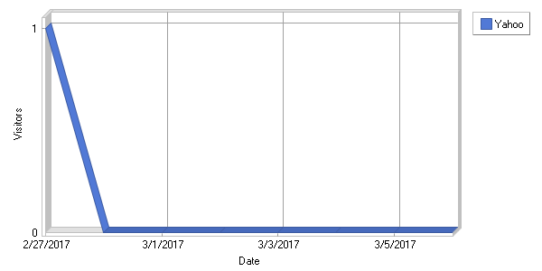

**Top Search Engines**  
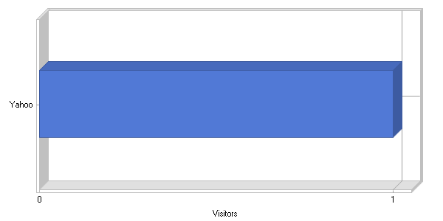

**Top Search Engines**

|  |
| --- |
|  |

|  |  |  |  |  |  |  |  |  |  |
| --- | --- | --- | --- | --- | --- | --- | --- | --- | --- |
| |  |  |  | | --- | --- | --- | |  | **Search Engine** | **Visitors** | | 1 | Yahoo | 1 | |  | **Total** | **1** | |

|  |  |  |
| --- | --- | --- |
| C:\ProgramData\WebLog Expert Lite\Report\index_files\section_left.gif | **Search Phrases** | C:\ProgramData\WebLog Expert Lite\Report\index_files\section_right.gif |

**Top Search Phrases**

|  |
| --- |
|  |

|  |  |  |  |  |  |  |  |  |  |
| --- | --- | --- | --- | --- | --- | --- | --- | --- | --- |
| |  |  |  | | --- | --- | --- | |  | **Phrase** | **Visitors** | | 1 | Phrase Not Provided | 1 | |  | **Total** | **1** | |

|  |  |  |
| --- | --- | --- |
| C:\ProgramData\WebLog Expert Lite\Report\index_files\section_left.gif | **Browsers** | C:\ProgramData\WebLog Expert Lite\Report\index_files\section_right.gif |

**Daily Used Browsers**  
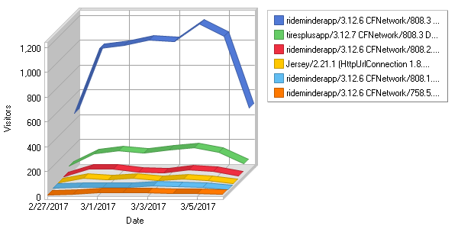

**Most Used Browsers**  
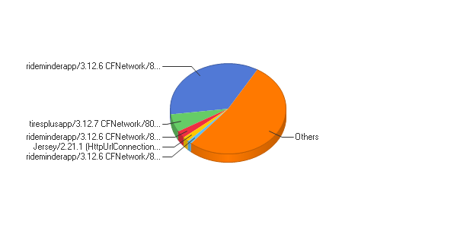

**Most Used Browsers**

|  |
| --- |
|  |

|  |  |  |  |  |  |  |  |  |  |  |  |  |  |  |  |  |  |  |  |  |  |  |  |  |  |  |  |  |  |  |  |  |  |  |  |  |  |  |  |  |  |  |  |  |  |  |  |  |  |  |  |  |  |  |  |  |  |  |  |  |  |  |  |  |  |  |  |  |  |  |  |  |  |  |  |  |  |  |  |  |  |  |  |  |  |  |  |  |  |  |  |  |  |  |  |  |  |  |  |  |  |  |  |  |  |  |  |  |  |  |  |  |  |  |  |  |  |  |  |  |  |  |  |  |  |  |  |  |  |  |  |  |  |  |  |  |  |  |  |  |  |  |  |  |  |  |  |  |  |  |  |  |  |  |  |  |  |  |  |  |  |  |  |  |  |  |  |  |  |  |  |  |  |  |  |  |  |  |  |  |  |  |  |  |  |  |  |  |  |  |  |  |  |  |  |  |  |  |  |  |  |  |  |  |  |  |  |  |  |  |  |  |  |  |  |  |  |  |  |  |  |  |  |  |  |  |  |  |  |  |  |  |  |  |  |  |  |  |  |  |  |  |  |  |  |  |  |  |  |  |  |  |  |  |  |  |  |  |  |  |  |  |  |  |  |
| --- | --- | --- | --- | --- | --- | --- | --- | --- | --- | --- | --- | --- | --- | --- | --- | --- | --- | --- | --- | --- | --- | --- | --- | --- | --- | --- | --- | --- | --- | --- | --- | --- | --- | --- | --- | --- | --- | --- | --- | --- | --- | --- | --- | --- | --- | --- | --- | --- | --- | --- | --- | --- | --- | --- | --- | --- | --- | --- | --- | --- | --- | --- | --- | --- | --- | --- | --- | --- | --- | --- | --- | --- | --- | --- | --- | --- | --- | --- | --- | --- | --- | --- | --- | --- | --- | --- | --- | --- | --- | --- | --- | --- | --- | --- | --- | --- | --- | --- | --- | --- | --- | --- | --- | --- | --- | --- | --- | --- | --- | --- | --- | --- | --- | --- | --- | --- | --- | --- | --- | --- | --- | --- | --- | --- | --- | --- | --- | --- | --- | --- | --- | --- | --- | --- | --- | --- | --- | --- | --- | --- | --- | --- | --- | --- | --- | --- | --- | --- | --- | --- | --- | --- | --- | --- | --- | --- | --- | --- | --- | --- | --- | --- | --- | --- | --- | --- | --- | --- | --- | --- | --- | --- | --- | --- | --- | --- | --- | --- | --- | --- | --- | --- | --- | --- | --- | --- | --- | --- | --- | --- | --- | --- | --- | --- | --- | --- | --- | --- | --- | --- | --- | --- | --- | --- | --- | --- | --- | --- | --- | --- | --- | --- | --- | --- | --- | --- | --- | --- | --- | --- | --- | --- | --- | --- | --- | --- | --- | --- | --- | --- | --- | --- | --- | --- | --- | --- | --- | --- | --- | --- | --- | --- | --- | --- | --- | --- | --- | --- | --- | --- | --- | --- | --- | --- | --- | --- | --- | --- | --- | --- | --- | --- | --- | --- | --- |
| |  |  |  |  |  | | --- | --- | --- | --- | --- | |  | **Browser** | **Hits** | **Visitors** | **% of Total Visitors** | | 1 | Others | 28,493 | 9,064 | 44.10% | | 2 | rideminderapp/3.12.6 CFNetwork/808.3 Darwin/16.3.0 | 28,961 | 7,263 | 35.34% | | 3 | tiresplusapp/3.12.7 CFNetwork/808.3 Darwin/16.3.0 | 5,526 | 1,319 | 6.42% | | 4 | rideminderapp/3.12.6 CFNetwork/808.2.16 Darwin/16.3.0 | 2,278 | 539 | 2.62% | | 5 | Jersey/2.21.1 (HttpUrlConnection 1.8.0\_112) | 5,179,872 | 367 | 1.79% | | 6 | rideminderapp/3.12.6 CFNetwork/808.1.4 Darwin/16.1.0 | 745 | 239 | 1.16% | | 7 | rideminderapp/3.12.6 CFNetwork/758.5.3 Darwin/15.6.0 | 815 | 200 | 0.97% | | 8 | rideminderapp/3.12.6 CFNetwork/808.0.2 Darwin/16.0.0 | 683 | 193 | 0.94% | | 9 | rideminderapp/3.11 CFNetwork/808.3 Darwin/16.3.0 | 212 | 74 | 0.36% | | 10 | Google Chrome | 20,456 | 73 | 0.36% | | 11 | Apache-HttpClient/4.4.1 (Java/1.8.0\_112) | 482 | 72 | 0.35% | | 12 | tiresplusapp/3.12.7 CFNetwork/808.2.16 Darwin/16.3.0 | 275 | 72 | 0.35% | | 13 | Internet Explorer | 887 | 53 | 0.26% | | 14 | tiresplusapp/3.12.7 CFNetwork/808.1.4 Darwin/16.1.0 | 285 | 52 | 0.25% | | 15 | rideminderapp/3.12.6 CFNetwork/811.4.18 Darwin/16.5.0 | 178 | 46 | 0.22% | | 16 | tiresplusapp/3.12.7 CFNetwork/758.5.3 Darwin/15.6.0 | 176 | 37 | 0.18% | | 17 | rideminderapp/3.12.6 CFNetwork/758.4.3 Darwin/15.5.0 | 130 | 35 | 0.17% | | 18 | rideminderapp/3.12.6 CFNetwork/811.4.16 Darwin/16.5.0 | 129 | 35 | 0.17% | | 19 | CopperEgg/RevealUptime/N.VirginiaUSA | 1,012 | 32 | 0.16% | | 20 | tiresplusapp/3.12.7 CFNetwork/808.0.2 Darwin/16.0.0 | 114 | 30 | 0.15% | | 21 | CopperEgg/RevealUptime/DallasTXUSA | 970 | 29 | 0.14% | | 22 | Java/1.8.0\_112 | 115 | 27 | 0.13% | | 23 | CopperEgg/RevealUptime/AtlantaGAUSA | 990 | 26 | 0.13% | | 24 | CopperEgg/RevealUptime/ | 981 | 26 | 0.13% | | 25 | Mobile Safari | 7,147 | 24 | 0.12% | | 26 | rideminderapp/3.12.6 CFNetwork/758.3.15 Darwin/15.4.0 | 69 | 24 | 0.12% | | 27 | rideminderapp/3.10.0 CFNetwork/808.3 Darwin/16.3.0 | 42 | 23 | 0.11% | | 28 | CopperEgg/RevealUptime/FremontCAUSA | 1,023 | 22 | 0.11% | | 29 | rideminderapp/3.12.6 CFNetwork/758.2.8 Darwin/15.0.0 | 85 | 21 | 0.10% | | 30 | CopperEgg/RevealUptime/NewarkNJUSA | 1,022 | 20 | 0.10% | | 31 | CopperEgg/RevealUptime/OregonUSA | 1,017 | 19 | 0.09% | | 32 | PostmanRuntime/3.0.11-hotfix.2 | 60 | 16 | 0.08% | | 33 | rideminderapp/3.12.6 CFNetwork/672.1.15 Darwin/14.0.0 | 65 | 15 | 0.07% | | 34 | rideminderapp/3.12.6 CFNetwork/758.1.6 Darwin/15.0.0 | 54 | 12 | 0.06% | | 35 | rideminderapp/3.11 CFNetwork/808.2.16 Darwin/16.3.0 | 20 | 12 | 0.06% | | 36 | Android Browser | 630 | 10 | 0.05% | | 37 | Firefox | 394 | 10 | 0.05% | | 38 | tiresplusapp/3.11 CFNetwork/808.3 Darwin/16.3.0 | 24 | 9 | 0.04% | | 39 | rideminderapp/3.10.0 CFNetwork/808.2.16 Darwin/16.3.0 | 17 | 9 | 0.04% | | 40 | rideminderapp/3.12.7 CFNetwork/808.2.16 Darwin/16.0.0 | 38 | 9 | 0.04% | | 41 | tiresplusapp/3.12.7 CFNetwork/758.2.8 Darwin/15.0.0 | 35 | 8 | 0.04% | | 42 | rideminderapp/3.9.0 CFNetwork/808.3 Darwin/16.3.0 | 19 | 8 | 0.04% | | 43 | rideminderapp/3.10.0 CFNetwork/808.0.2 Darwin/16.0.0 | 19 | 7 | 0.03% | | 44 | curl/7.22.0 (x86\_64-pc-linux-gnu) libcurl/7.22.0 OpenSSL/1.0.1 zlib/1.2.3.4 libidn/1.23 librtmp/2.3 | 8 | 7 | 0.03% | | 45 | tiresplusapp/3.12.7 CFNetwork/811.4.16 Darwin/16.5.0 | 30 | 7 | 0.03% | | 46 | tiresplusapp/3.12.7 CFNetwork/758.4.3 Darwin/15.5.0 | 23 | 6 | 0.03% | | 47 | rideminderapp/3.11 CFNetwork/808.1.4 Darwin/16.1.0 | 17 | 6 | 0.03% | | 48 | rideminderapp/3.11 CFNetwork/758.5.3 Darwin/15.6.0 | 26 | 6 | 0.03% | | 49 | rideminderapp/3.8.1 CFNetwork/808.3 Darwin/16.3.0 | 32 | 6 | 0.03% | | 50 | rideminderapp/3.10.0 CFNetwork/808.1.4 Darwin/16.1.0 | 6 | 6 | 0.03% | |  | **Subtotal** | **5,286,687** | **20,225** | **98.41%** | |  | **Total** | **5,288,298** | **20,552** | **100.00%** | |

|  |  |  |
| --- | --- | --- |
| C:\ProgramData\WebLog Expert Lite\Report\index_files\section_left.gif | **IE and Edge Versions** | C:\ProgramData\WebLog Expert Lite\Report\index_files\section_right.gif |

**Daily Internet Explorer and Microsoft Edge Versions**  
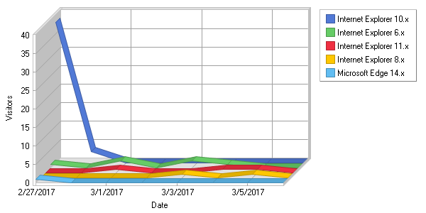

**Internet Explorer and Microsoft Edge Versions**  
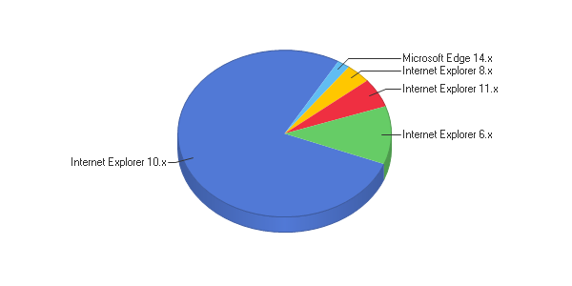

**Internet Explorer and Microsoft Edge Versions**

|  |
| --- |
|  |

|  |  |  |  |  |  |  |  |  |  |  |  |  |  |  |  |  |  |  |  |  |  |  |  |  |  |  |  |  |  |  |  |  |  |  |  |
| --- | --- | --- | --- | --- | --- | --- | --- | --- | --- | --- | --- | --- | --- | --- | --- | --- | --- | --- | --- | --- | --- | --- | --- | --- | --- | --- | --- | --- | --- | --- | --- | --- | --- | --- | --- |
| |  |  |  |  |  | | --- | --- | --- | --- | --- | |  | **Browser** | **Hits** | **Visitors** | **% of Total Visitors** | | 1 | Internet Explorer 10.x | 83 | 41 | 77.36% | | 2 | Internet Explorer 6.x | 8 | 6 | 11.32% | | 3 | Internet Explorer 11.x | 167 | 3 | 5.66% | | 4 | Internet Explorer 8.x | 2 | 2 | 3.77% | | 5 | Microsoft Edge 14.x | 1,107 | 1 | 1.89% | |  | **Total** | **1,367** | **53** | **100.00%** | |

|  |  |  |
| --- | --- | --- |
| C:\ProgramData\WebLog Expert Lite\Report\index_files\section_left.gif | **Operating Systems** | C:\ProgramData\WebLog Expert Lite\Report\index_files\section_right.gif |

**Daily Used Operating Systems**  
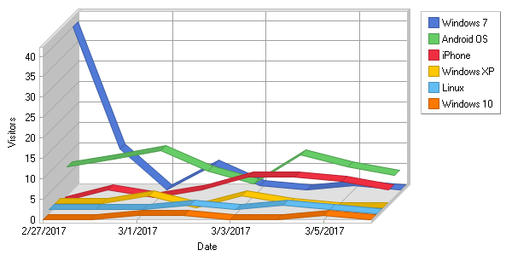

**Most Used Operating Systems**  
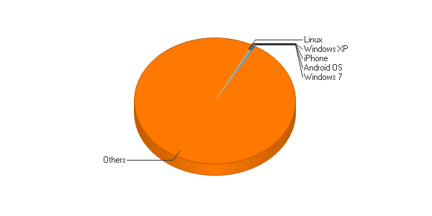

**Most Used Operating Systems**

|  |
| --- |
|  |

|  |  |  |  |  |  |  |  |  |  |  |  |  |  |  |  |  |  |  |  |  |  |  |  |  |  |  |  |  |  |  |  |  |  |  |  |  |  |  |  |  |  |  |  |  |  |  |  |  |  |  |  |  |  |  |  |  |  |  |  |  |  |  |  |  |  |  |  |  |  |  |  |  |  |  |  |  |  |  |  |  |  |  |  |  |  |  |  |  |  |  |  |  |  |  |  |
| --- | --- | --- | --- | --- | --- | --- | --- | --- | --- | --- | --- | --- | --- | --- | --- | --- | --- | --- | --- | --- | --- | --- | --- | --- | --- | --- | --- | --- | --- | --- | --- | --- | --- | --- | --- | --- | --- | --- | --- | --- | --- | --- | --- | --- | --- | --- | --- | --- | --- | --- | --- | --- | --- | --- | --- | --- | --- | --- | --- | --- | --- | --- | --- | --- | --- | --- | --- | --- | --- | --- | --- | --- | --- | --- | --- | --- | --- | --- | --- | --- | --- | --- | --- | --- | --- | --- | --- | --- | --- | --- | --- | --- | --- | --- | --- |
| |  |  |  |  |  | | --- | --- | --- | --- | --- | |  | **Operating System** | **Hits** | **Visitors** | **% of Total Visitors** | | 1 | Others | 5,257,650 | 20,059 | 99.17% | | 2 | Windows 7 | 1,107 | 58 | 0.29% | | 3 | Android OS | 19,311 | 58 | 0.29% | | 4 | iPhone | 6,928 | 27 | 0.13% | | 5 | Windows XP | 50 | 9 | 0.04% | | 6 | Linux | 40 | 9 | 0.04% | | 7 | Windows 10 | 1,124 | 3 | 0.01% | | 8 | Mac OS | 583 | 2 | 0.01% | | 9 | iPad | 874 | 1 | 0.00% | | 10 | Windows Vista | 22 | 0 | 0.00% | | 11 | iPod | 99 | 0 | 0.00% | | 12 | Windows Server 2003 | 3 | 0 | 0.00% | | 13 | Chrome OS | 125 | 0 | 0.00% | | 14 | BlackBerry | 2 | 0 | 0.00% | | 15 | Windows 8 | 20 | 0 | 0.00% | | 16 | Windows Phone | 130 | 0 | 0.00% | | 17 | Windows 8.1 | 230 | 0 | 0.00% | |  | **Total** | **5,288,298** | **20,226** | **100.00%** | |

|  |  |  |
| --- | --- | --- |
| C:\ProgramData\WebLog Expert Lite\Report\index_files\section_left.gif | **Types** | C:\ProgramData\WebLog Expert Lite\Report\index_files\section_right.gif |

**Daily Error Types**  
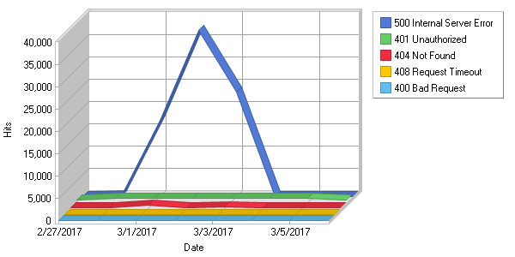

**Error Types**  
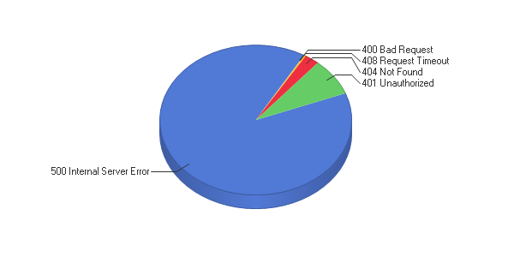

**Error Types**

|  |
| --- |
|  |

|  |  |  |  |  |  |  |  |  |  |  |  |  |  |  |  |  |  |  |  |  |  |
| --- | --- | --- | --- | --- | --- | --- | --- | --- | --- | --- | --- | --- | --- | --- | --- | --- | --- | --- | --- | --- | --- |
| |  |  |  | | --- | --- | --- | |  | **Error** | **Hits** | | 1 | 500 Internal Server Error | 78,144 | | 2 | 401 Unauthorized | 7,021 | | 3 | 404 Not Found | 2,168 | | 4 | 408 Request Timeout | 213 | | 5 | 400 Bad Request | 72 | |  | **Total** | **87,618** | |